**AI-Powered NGO Donation & Impact Management System**

**Project overview & success criteria**

Goal: Build an NGO-focused donation & impact management product using Salesforce as the primary platform. Add AI-powered features (donor intent detection, campaign recommendations, impact summarization) via external services. Primary personas: Donor, NGO Admin, Field Worker, Volunteer, Finance Officer, Reporting Analyst. Success metrics (KPIs): donation conversion rate, time-to-acknowledgement, repeat-donor rate, impact-closure rate, report accuracy.

**Table of contents**

1. P**roject overview & success criteria**
2. **Phase 0 — Discovery & Requirements (line-by-line)**
3. **Phase 1 — Architecture & System design (line-by-line)**
4. **Phase 2 — Data model & metadata (objects, fields, relationships)**
5. **Phase 3 — Integrations & external services (payments, AI)**
6. **Phase 4 — Core features implementation (donation, campaigns)**
7. **Phase 5 — AI features implementation (NLP, recommendations, summarization)**
8. **Phase 6 — Reporting, dashboards & impact analytics**
9. **Phase 7 — Security, tests & compliance**
10. **Phase 8 — Packaging, release & CI/CD**
11. **Phase 9 — Operations, monitoring & backups**
12. **Phase 10 — Documentation, training & handover**
13. **emo video: storyboard, script, recording & editing checklist**
14. **Appendix: commands, sample metadata layout, sample test data commands**

**Industry: Non-Profit / Social Services**

**Project Type: B2C Salesforce CRM Implementation with AI & Automation**

**Target Users: NGO Teams, Donors, Volunteers, Campaign Managers**

**Problem Statement**

Many Non-Governmental Organizations (NGOs) still rely on spreadsheets, emails, and manual registers to manage donors, track donations, and run campaigns. This results in:

* **Missed or untracked donations** – leading to revenue loss
* **Duplicate donor records** – causing data inconsistency and confusion
* **No automated follow-up or acknowledgment** – weakening donor relationships
* **Difficulty in showing donation utilization** – reducing donor trust
* **Lack of real-time reports** – making decision-making slow and reactive

To address these challenges, the NGO plans to implement a Salesforce-based NGO & Donation Management CRM, which will:

* **Centralize donor data** in one system for accuracy and easy access
* **Track donations** and auto-generate receipts
* **Send automated thank-you emails/SMS** immediately after donations
* **Manage multiple campaigns** and display progress in real time
* **Provide interactive dashboards** for transparency and data-driven decision

**Use Cases**

1. **Donor Registration & History Tracking:** Register new donors, avoid duplicates, and maintain a complete donation history for each donor.
2. **Donation Tracking & Automated Receipts:** Record donations, update donor totals automatically, and send acknowledgment receipts via email/SMS.
3. **Campaign Creation & Progress Monitoring:** Create fundraising campaigns, monitor funds raised, and view real-time progress on dashboards.
4. **Real-Time Reporting & Insights:** Provide management with dashboards showing donation trends, top donors, and campaign performance for data-driven decisions.

**Business Process Flow:**

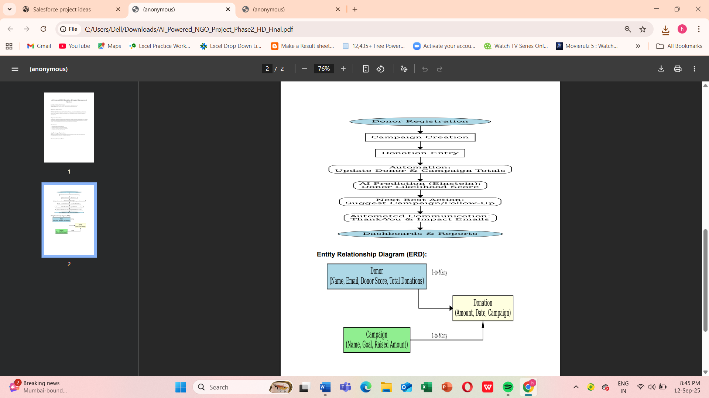

**Entity Relationship Diagram (ERD):**



**Phase-2: Org Setup & Configuration**

This phase focuses on setting up the Salesforce environment to support NGO operations, donation tracking, and impact management. It ensures proper configurations, security, and user access to align with organizational processes.

**Use Cases:User Role Management:**

* + Assign Fundraising Officers to see only their donations.
  + Admins can view and manage all donations and campaigns.

**Permission Control:**

* + Profiles and Permission Sets ensure staff can create, view, or edit donation records as per their role.

**Security & Sharing Rules:**

* + Private OWD ensures confidential donor data is protected.
  + Sharing rules allow officers to see only relevant donations.

**1. Salesforce Editions**

Salesforce offers multiple editions, each with varying features. Choosing the right edition is crucial for NGO operations.

**Step:**

1. Navigate to **Setup → Company Settings → Company Information**.
2. Check the **Salesforce Edition** field.

**Recommendation for NGO Project:**

* **Enterprise edition** provides custom objects, workflows, API access, and automation rules, which are crucial for an AI-powered system that tracks donations and impact metrics.
* **Nonprofit Success Pack (NPSP)** which Built on Enterprise Edition; ideal for NGOs.

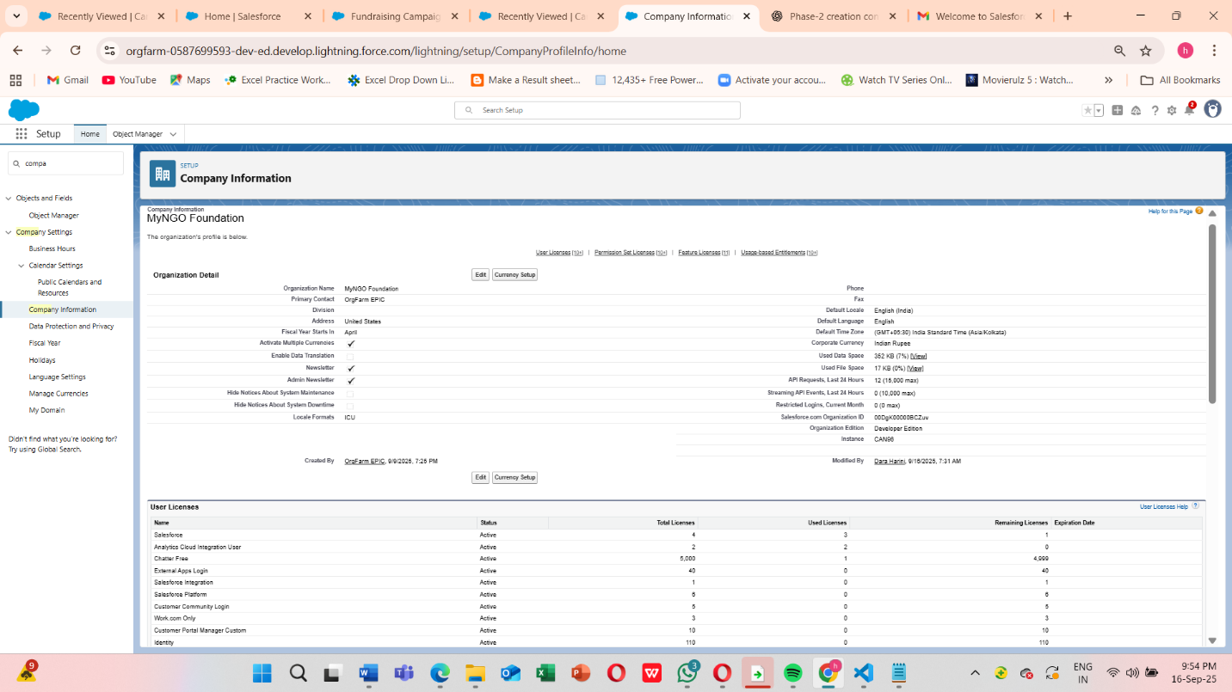

**2. Company Profile Setup**

Set up your company information to ensure correct branding and reporting.

**Steps:**

1. **Setup → Company Settings → Company Information**.
2. Fill in:
   * **Company Name**: “AI-Powered NGO Donation System”
   * **Primary Contact**
   * **Default Locale, Time Zone**
   * **Default Currency** (important if your NGO accepts multiple currencies)
3. Save changes.

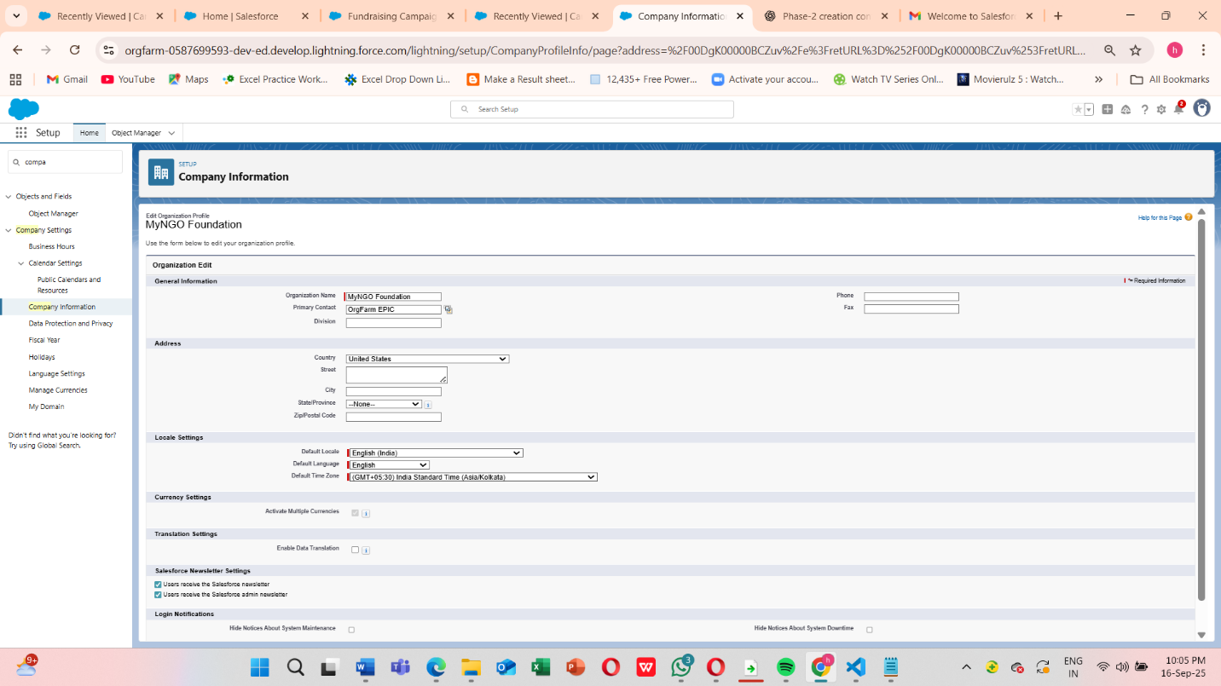

Ensures that reports, dashboards, and automated processes show accurate and localized data and Accurate company info ensures correct reporting, date/time handling, and currency calculations.

**3. Business Hours & Holidays**

NGOs often have operations that need accurate service availability settings (for donor support, case management, etc.).

**Steps:**

1. Go to **Setup → Company Settings → Business Hours**.
2. Click **New** → Define standard hours for donor support (e.g., Mon-Fri, 9 AM–6 PM).

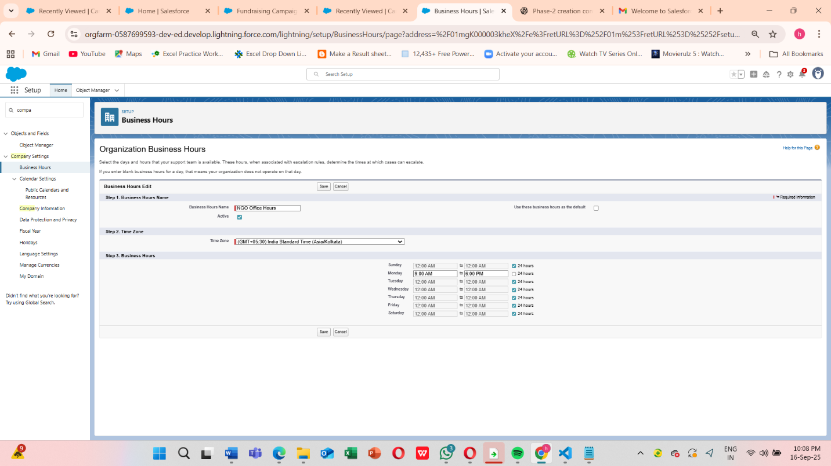

1. Setup → Holidays
2. Click New Holiday -> Add NGO-specific holidays (e.g., Foundation Day, Public Holidays)

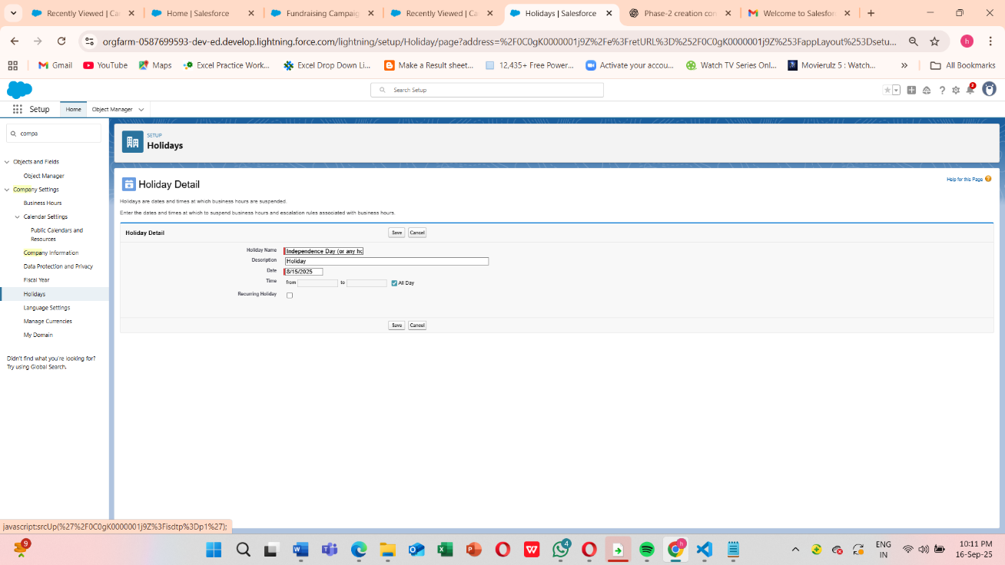

Business Hours page with list view showing “NGO Operating Hours”. Holidays page listing multiple entries.

* Ensures that **case escalation rules, automated workflows, and AI notifications** respect business hours.

**4. Fiscal Year Settings**

This controls reporting and financial tracking for donations.

**Steps:**

1. **Setup → Company Settings → Fiscal Year**
2. Choose either **Standard Fiscal Year** (Jan–Dec) or **Custom Fiscal Year** (e.g., NGO operates Apr–Mar).
3. Save changes.

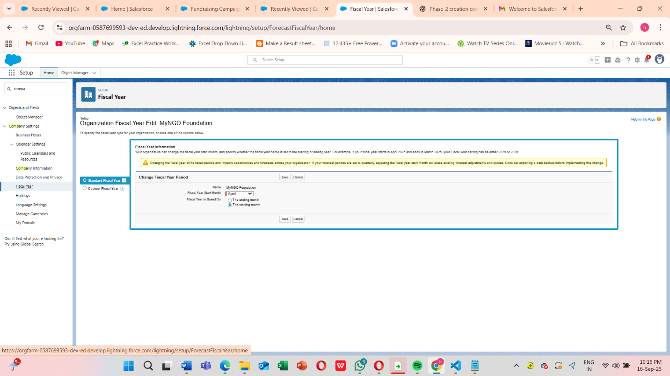

Fiscal Year page showing the selected start month and period.

Accurate **donation reports, grant tracking, and AI predictions** rely on correct fiscal periods.

**5. User Setup & Licenses -> Creating Role Hierarchy**

Users must have proper licenses to access Salesforce features.

**Steps:**

1. **Setup → Users → Users → New User**
2. Assign:
   * **Full Name**
   * **Email**
   * **Role**
   * **Profile**
   * **License Type** (Salesforce Platform / Salesforce / Chatter Only)
3. Save and send **login credentials**.

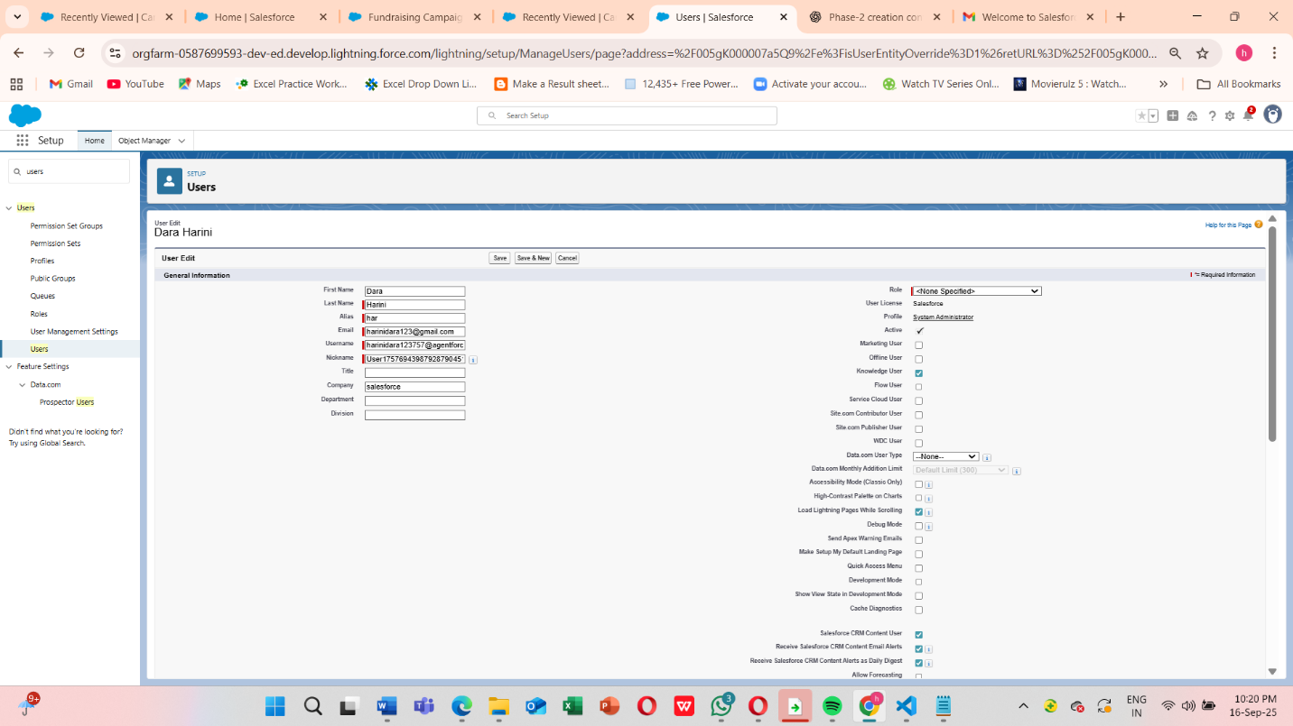

Licenses define **permissions, access to objects, and AI features**. For example, a fundraiser may need full Salesforce license, while a volunteer coordinator may need only platform license.

New User” form with fields for Name, Email, Profile, Role, and License.

**6. Profiles**

Profiles define **baseline permissions** for objects, fields, and tabs.

**Steps:**

1. **Setup → Users → Profiles**
2. Create **custom profiles**:
   * Fundraiser Profile → Access to Donations, Campaigns, Reports
   * Volunteer Profile → Access to Cases, Tasks
   * Admin Profile → Full Access
3. Assign profiles to users.

**Roles**

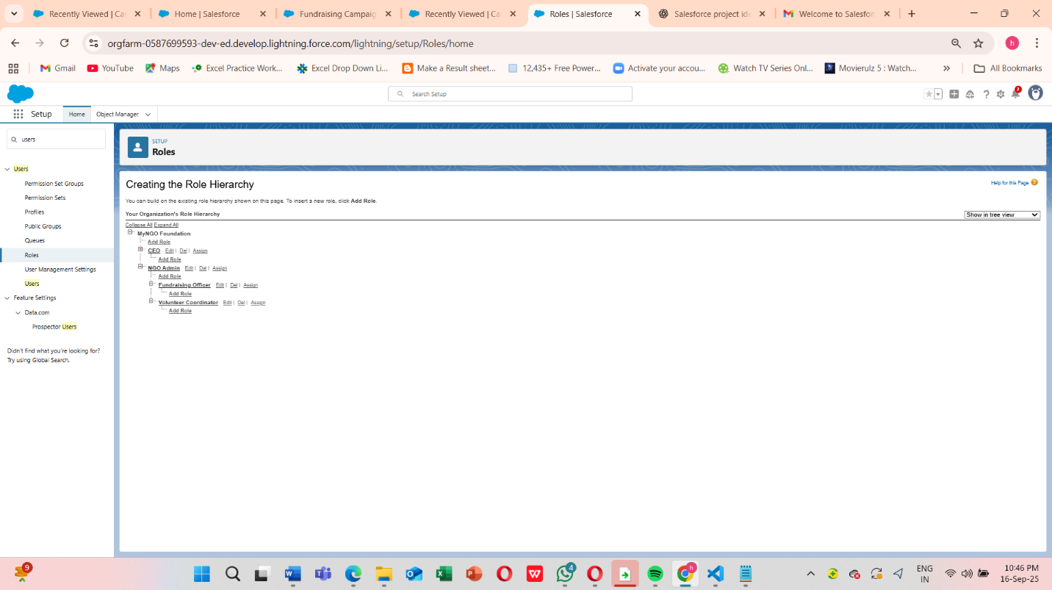

This is Profile detail page with object permissions visible.

**Note** : Before Implementing Permission sets we need to complete the profile process

**Create Permission Sets**

Setup → Permission Sets

**Steps:**

1. Click **New** → Name: Campaign_Access_PS
2. Object Settings → Campaign → Enable Read & Edit access
3. Assign this permission set to your **Fundraising Officer** user

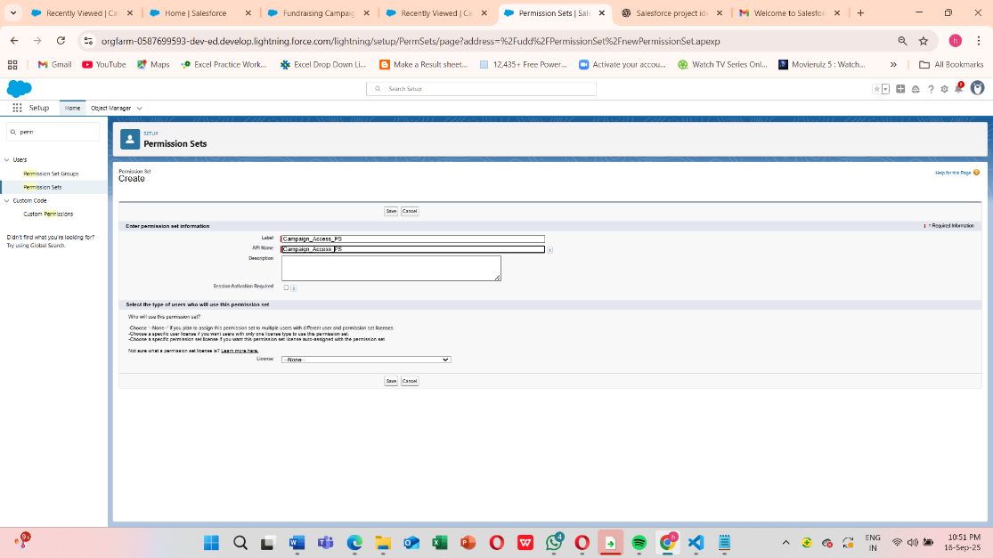I

In Object settings , we see ->

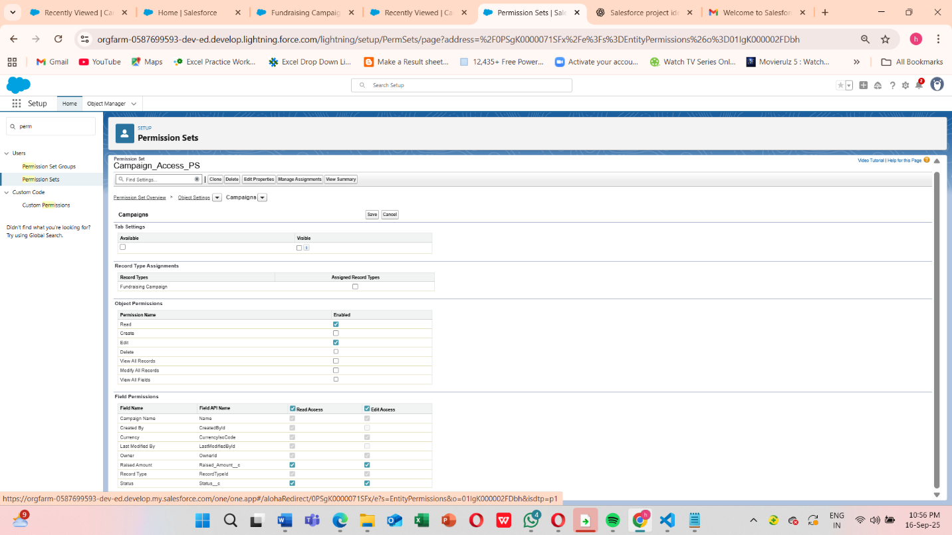

Finally , **Assign Roles to Users**

* Go to **Setup → Users → Users**
* Edit your Officer, Fundraising user → set **Role = Fundraising Officer**
* Save

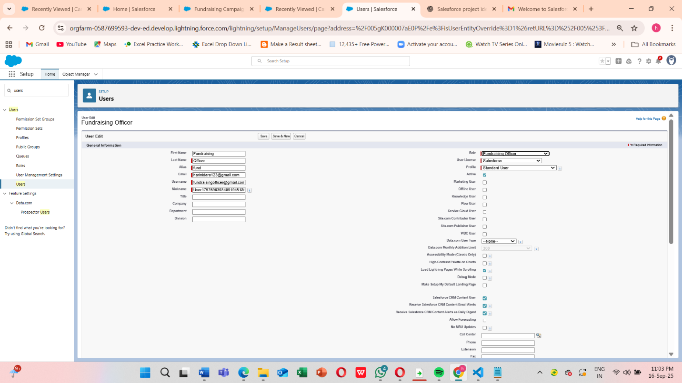

**7.Set OWD (Organization-Wide Defaults)**

Donor & Donation data must be private by default.

* Setup → Sharing Settings
* Set Donor & Donation OWD = **Private**
* Save

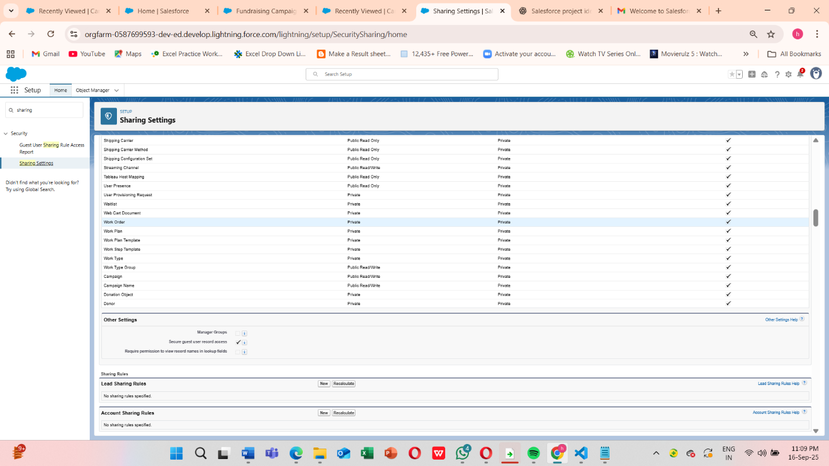



This ensures **donor confidentiality** while allowing collaboration on campaign-related activities

**8.Sharing Rules**

Sharing rules were configured to extend record access where necessary:

* Donations shared with Fundraising Managers (Read/Write)
* Campaigns shared with all volunteers (Read Only)

This balances **security with collaboration**, ensuring that only authorized users can access sensitive donation information.

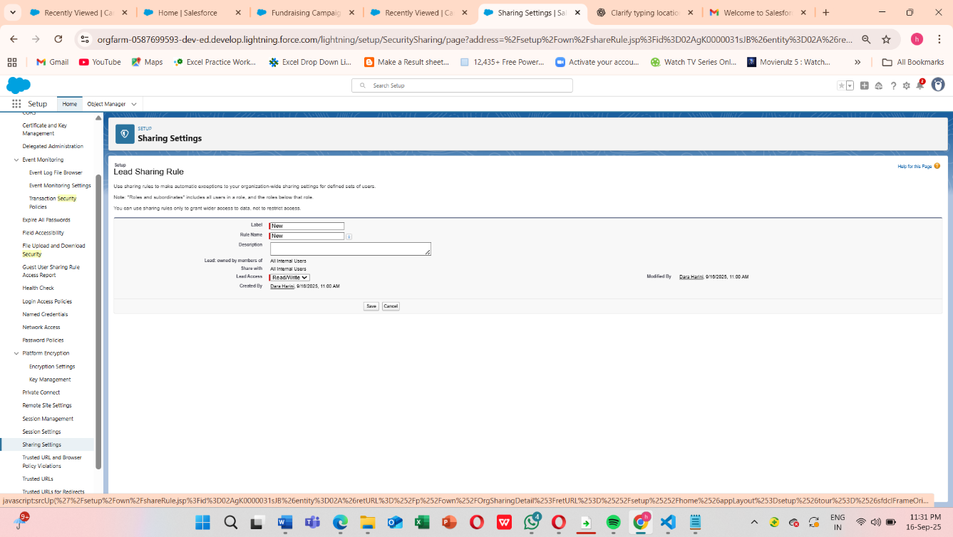

Share Donations with the **Manager role** so they can view all donations

**9.Login Access Policies**

Define’s how users access Salesforce securely.

1. Setup → Security → Login Access Policies
2. Enable Administrators Can Log in as Any User

**Administrator Login Access**

* Enabled the option: **“Administrators Can Log in as Any User.”**
* This allows system administrators to access user accounts temporarily for troubleshooting issues, resetting configurations, or assisting users facing login errors.

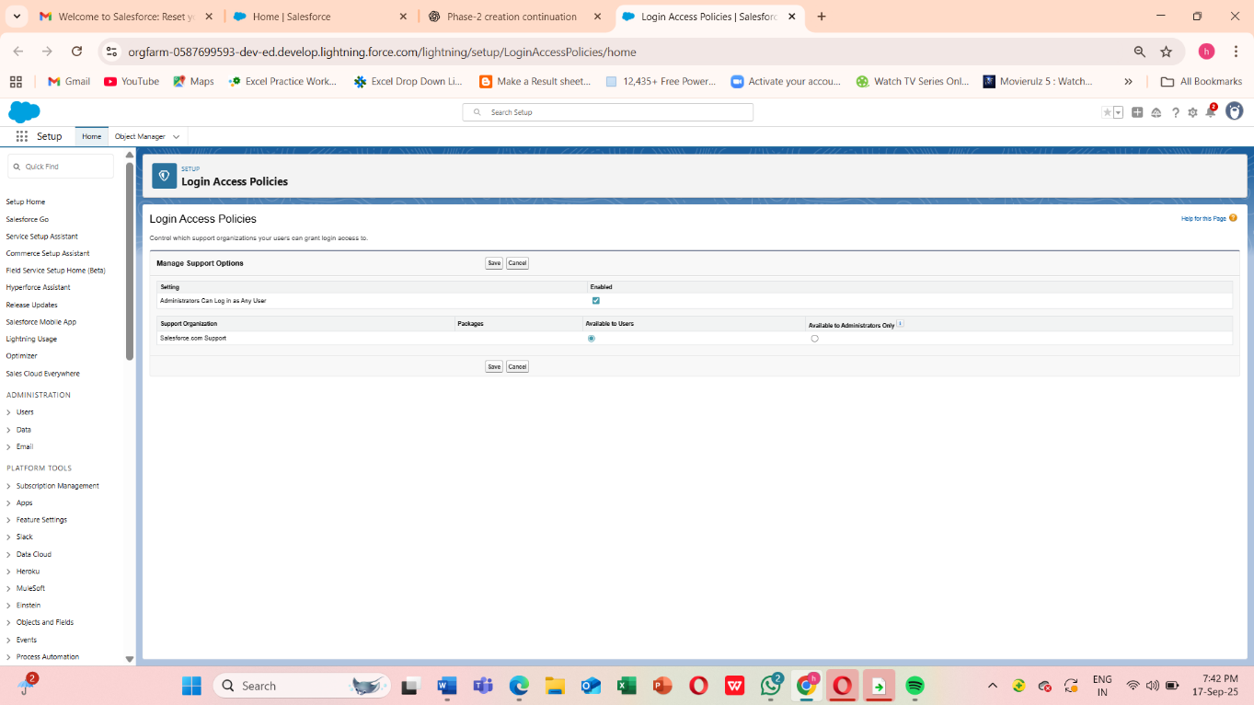

**Define Login Hours for Each Profile:**

**Fundraiser Profile**

* **Monday–Friday:** 8:00 AM → 8:00 PM
* **Saturday & Sunday:** None (to restrict access during off-hours)
* ✅ Why: Fundraisers usually work during business hours, handling donor relationships, campaigns, and donation records.

**Volunteer Profile**

* **Monday–Friday:** 7:00 AM → 9:00 PM
* **Saturday:** 9:00 AM → 6:00 PM
* **Sunday:** None
* ✅ Why: Volunteers may work flexible hours outside regular business timings, but restricting late-night access adds a layer of security.

**Admin Profile**

* **All Days:** 12:00 AM → 11:59 PM (Full Access)
* ✅ Why: Admins need unrestricted access since they may handle system issues or urgent donor support requests anytime.

**Save Settings** once the time slots are entered. Example :

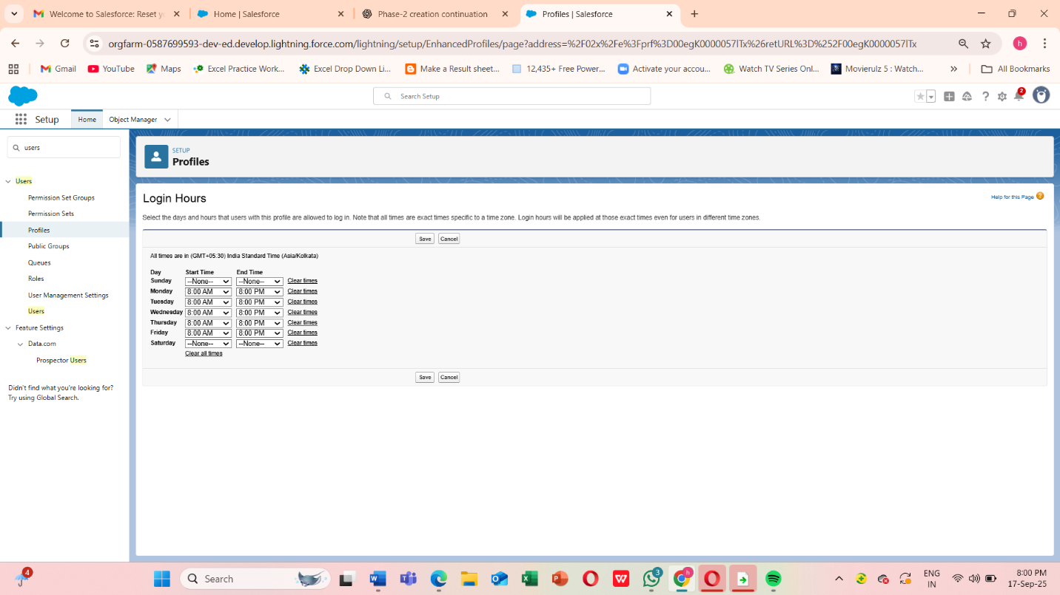

**10. Developer Org Setup**

To safely test and build our **AI-Powered NGO Donation & Impact Management System**, we created and configured a **Salesforce Developer Org**. A developer org acts as a **free sandbox environment** where new features, configurations, and AI functionalities can be built and validated without affecting live donor or campaign data.

Step 1 - Sign up: [https://developer.salesforce.com/signup] or developer.salesforce.com/signup.

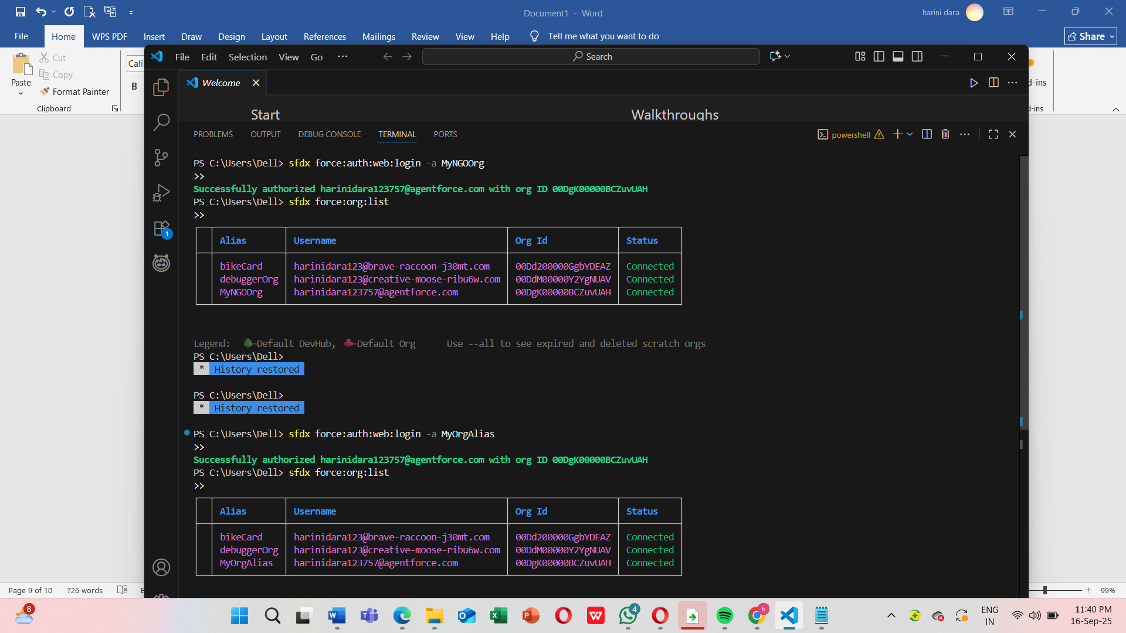

**Connecting Your Org with VS Code**

Since you've already set up your Salesforce org and connected it with VS Code, you can now manage and deploy your metadata locally. Here's how to proceed:

**1. Authenticate Salesforce CLI with Your Org**

If you haven't authenticated yet, run the following command in your VS Code terminal:

**sfdx force:auth:web:login -a MyNGOOrg**

This will open a browser window for you to log in to your Salesforce org.

**2. Retrieve Metadata from Your Org**

To bring your existing objects and fields into VS Code, run:

**sfdx force:source:retrieve -m CustomObject:Donor,CustomObject:Campaign,CustomObject:Donation**

This command fetches the metadata for your Donor, Campaign, and Donation objects.

**3. Make Changes Locally**

* Edit fields, page layouts, or add new components as needed.
* Use VS Code's Salesforce extensions to streamline your development process.

**4. Deploy Changes Back to Salesforce**

After making changes, deploy them back to your org using:

**sfdx force:source:deploy -p force-app/main/default/objects/Donor__c**

**sfdx force:source:deploy -p force-app/main/default/objects/Campaign__c**

**sfdx force:source:deploy -p force-app/main/default/objects/Donation__c**

Step 2 - Finally we can implement Basic Setup

1. Basic Setup

* + Customized Company Information with NGO details.
  + Set up Business Hours, Fiscal Year, and Locale consistent with our main production org.
  + Installed NGO Donation App structure with custom objects:
    - Donations (to capture donor transactions)
    - Campaigns (for fundraising initiatives)
    - Volunteers (to track volunteer engagement)
    - Impact Metrics (to measure project outcomes)

2.AI Experimentation Space

* + Configured the org to test Einstein Prediction Builder for predicting donor retention.
  + Created sample datasets of donors and donations to train and validate AI models.
  + Validated that predictions and reports worked as expected.

3.Testing Security & Access Controls

* + Replicated Profiles, Roles, and Sharing Settings to simulate real NGO scenarios.
  + Tested Login Access Policies (Login Hours and IP Restrictions) in a safe environment.

Due to this

**Risk-Free Testing -** Ensures changes do not disrupt actual donor or campaign operations and **Consistency -** By mirroring production settings, the Developer Org helps validate how changes will perform in real scenarios.

**11.Sandbox Usage**

In a real-world Salesforce Enterprise Edition org, Sandboxes are used for testing and training before deploying to production. However, since our project is implemented in a **Salesforce Developer Edition**, the Sandbox feature is not available.

To simulate this, we used our **Developer Org as a testing environment**. All new configurations, workflows, and AI models were validated here before documenting them for production deployment.

**Conceptual Sandbox Usage in NGO Projects:**

* **Developer Sandbox:** For testing small configurations like workflows and validation rules.
* **Partial Copy Sandbox:** For testing donor and campaign features with sample records.
* **Full Sandbox:** For complete end-to-end testing with a copy of production data.

Even though our edition doesn’t support Sandboxes, the **Developer Org acted as our Sandbox substitute**, allowing us to:

* Safely test donation workflows and security settings
* Validate AI-powered donor retention predictions
* Simulate role-based access for fundraisers and volunteers

**12.Deployment Basics**

Deployment in Salesforce refers to the process of **moving configurations, customizations, and code** from one environment (like a Developer Org or Sandbox) to another (usually Production). For our **AI-Powered NGO Donation & Impact Management System**, deployment ensures that all the tested features — donor management, fundraising campaigns, AI predictions, and role-based security — move safely into the live environment where NGO staff will actually use them.

It clearly shows the process:

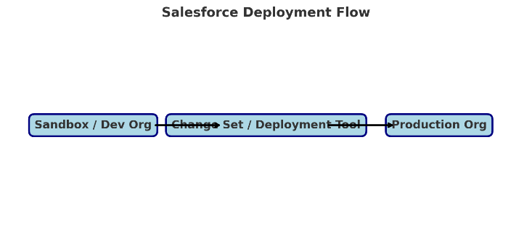

* Start from **Sandbox / Developer Org**
* Move changes using **Change Set / Deployment Tool (ANT, CLI, etc.)**
* Deploy into **Production Org**

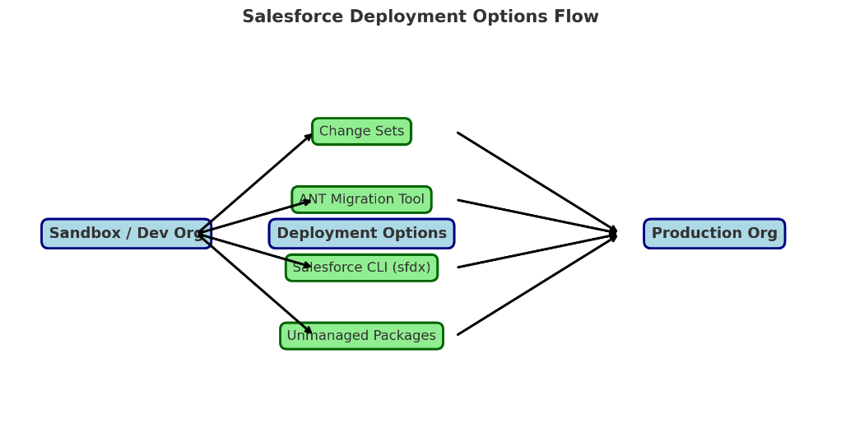

This diagram illustrates how configurations and customizations from the **Sandbox/Developer Org** can be moved to the **Production Org** using different deployment methods:

* **Change Sets** – Best for small, admin-friendly changes (fields, workflows, roles).
* **ANT Migration Tool** – Used for bulk deployments and automation.
* **Salesforce CLI (sfdx)** – Ideal for modern, source-driven deployments with version control.
* **Unmanaged Packages** – Useful in Developer Editions or when sharing modules across NGOs.

In our **AI-Powered NGO Donation & Impact Management System**, this ensures that tested features like donation workflows, AI predictions, and role-based access controls are safely migrated to the live production environment without disrupting ongoing NGO operations.

**Phase 3 — Data Modeling & Relationships**

**Goal:** design a clean, secure, scalable data model in Salesforce that supports donation processing, campaign tracking, volunteer management and AI-driven insights.

**Use Cases:**

**Donor Tracking:**

* + Each donation is linked to a donor to track total contributions.

**Campaign Association:**

* + Donations are connected to campaigns to monitor campaign performance.

**Fundraising Officer Assignment:**

* + Assign responsibility for donations to specific officers.

**Accurate Reporting:**

* + Relationships enable detailed reports by donor, campaign, or officer.

**1) Standard & Custom Objects**

* **Standard objects** are Salesforce-built (Account, Contact, Campaign, Opportunity, etc.). Use them where they fit — e.g., Contact for a donor or volunteer, Campaign for fundraising drives.
* **Custom objects** (<Name>__c) are created to hold project-specific data (e.g., Donation__c, Program__c, Impact_Report__c).

**How this maps to the NGO system**

Typical object list:

* **Standard:** Contact (donors/volunteers), Account (donor organizations), Campaign (fundraising campaigns).
* **Custom:**
  + Donation__c — each transaction (amount, date, payment method, receipt status).
  + Program__c — programs/projects that receive funding.
  + Impact_Report__c — outcome metrics and reports (beneficiaries served, KPIs).
  + Volunteer__c — volunteer detail if you need a richer volunteer record than Contact.

**How to View Standard Objects**

1. **Login** to Salesforce Developer Org.
2. Click on the ⚙️ **Setup** icon (top-right).
3. In the left sidebar Quick Find box → type **Object Manager**.
4. You’ll see a list of all objects.
   * Scroll → you’ll find **Account, Contact, Campaign, Opportunity, Case** etc.

This confirms standard objects are already available.

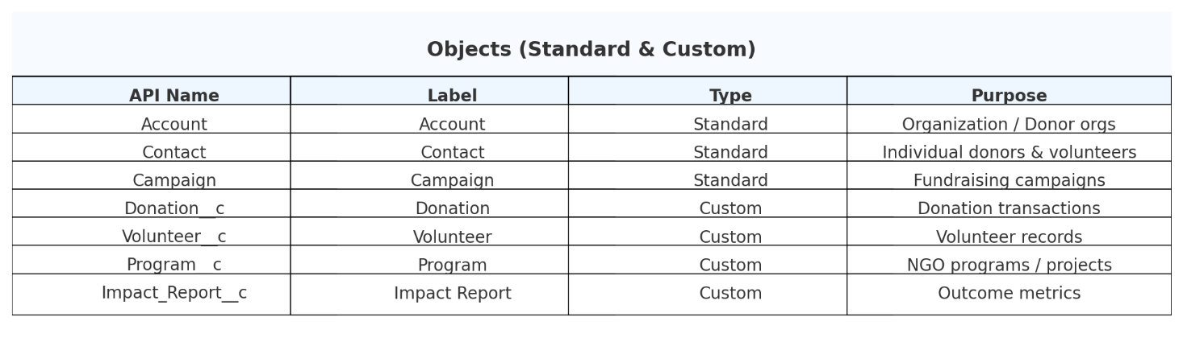

**How to create a custom object (step-by-step)**

1. Setup → **Object Manager** → **Create** → **Custom Object**.
2. Fill fields: **Label**, **Object Name (API)**, **Record Name** (Text or Auto-Number), enable **Allow Reports**, **Allow Activities**, enable **Track Field History** as needed.
3. Save and set permissions (Profiles / Permission Sets).

**Verify Your Custom Object**

After saving:

* Salesforce redirects to **Object Manager → Donation**.
* Here you can add **Fields**, **Page Layouts**, **Record Types**, etc.
* In the **App Launcher (9 dots)** → search “Donations” → you’ll see the new tab created.

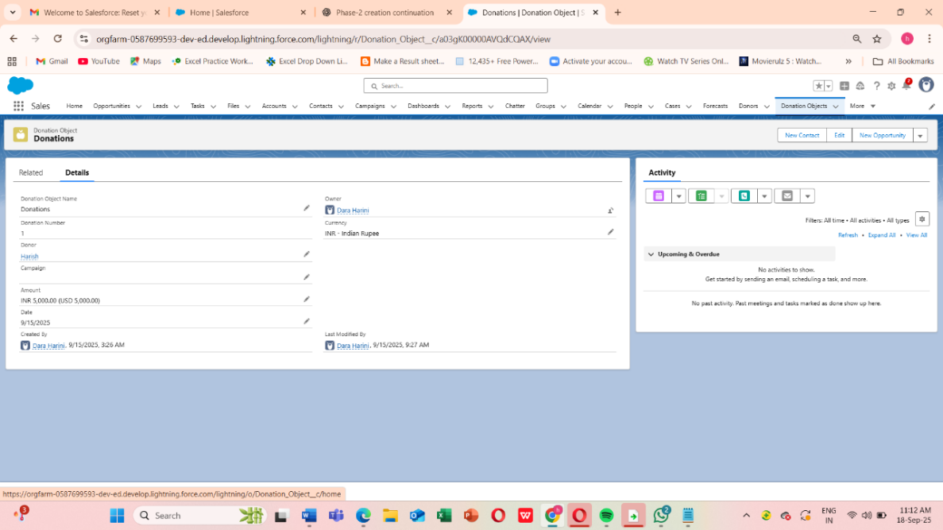



**2) Fields**

**Field types you will use (recommended for Donation)**

* Donation_Amount__c — **Currency** (required).
* Donor__c — **Lookup(Contact)** (required).
* Donation_Date__c — **Date** (required).
* Payment_Method__c — **Picklist** (e.g., Credit Card, Bank Transfer, Cash).
* Is_Recurring__c — **Checkbox**.
* Receipt_Sent__c — **Checkbox**.
* Campaign__c — **Lookup(Campaign)**.

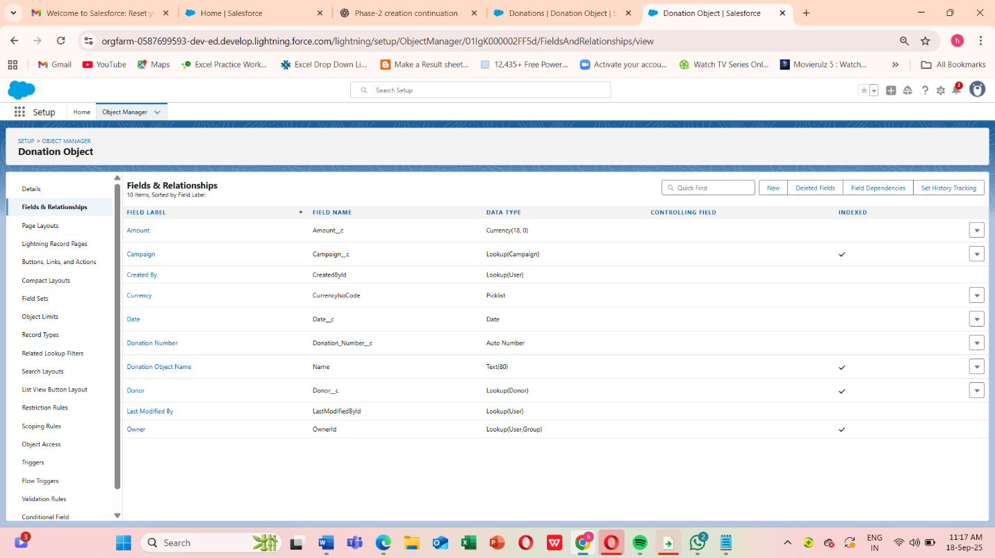

**Creating a field**

1. Setup → Object Manager → Select object (Donation) → **Fields & Relationships** → **New**.
2. Choose field type, click Next, configure label, length, help text, and set **Required** if needed.
3. Set **Field-Level Security** (Profiles) and add to Page Layouts. Save.

**Important field considerations**

* **Required vs optional:** Only make required what’s essential (e.g., donor, amount, date).
* **Help text**: Add help text to guide users.
* **Indexing:** Standard fields and some custom fields are indexed automatically. If queries get slow, consider marking a field as External ID or creating a custom index (via Salesforce support) for very large datasets.
* **Unique/External ID:** For import/lookup/upsert flows, mark donor external ID (like DonorID__c) to simplify deduping.

**3) Record Types**

**What record types do**

Record Types let you support different business processes, picklist values, and page layouts on the same object.

**Example use for donations**

* **Individual Donation** — fields relevant to an individual donor (Contact lookup prominent).
* **Corporate Donation** — additional fields for Company_Name__c, CSR_Project__c, Tax_Exemption__c.
* **Grant Payment** — additional compliance fields (Grant ID, Reporting requirements).

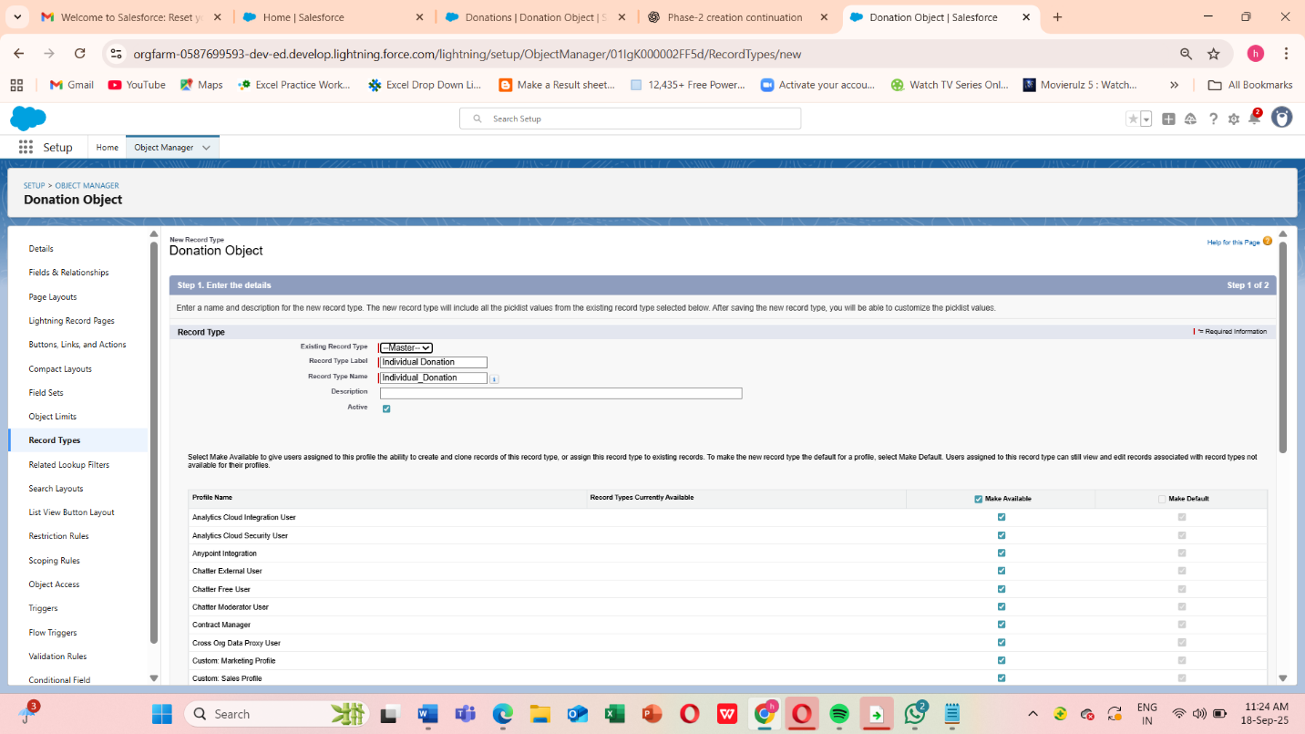

**Create Record Type (steps)**

1. Setup → Object Manager → Donation → **Record Types** → **New Record Type**.
2. Name the record type, set the default picklist values specific to that type.
3. Assign the record type to profiles, then create and assign matching Page Layouts to each profile/record type combo.

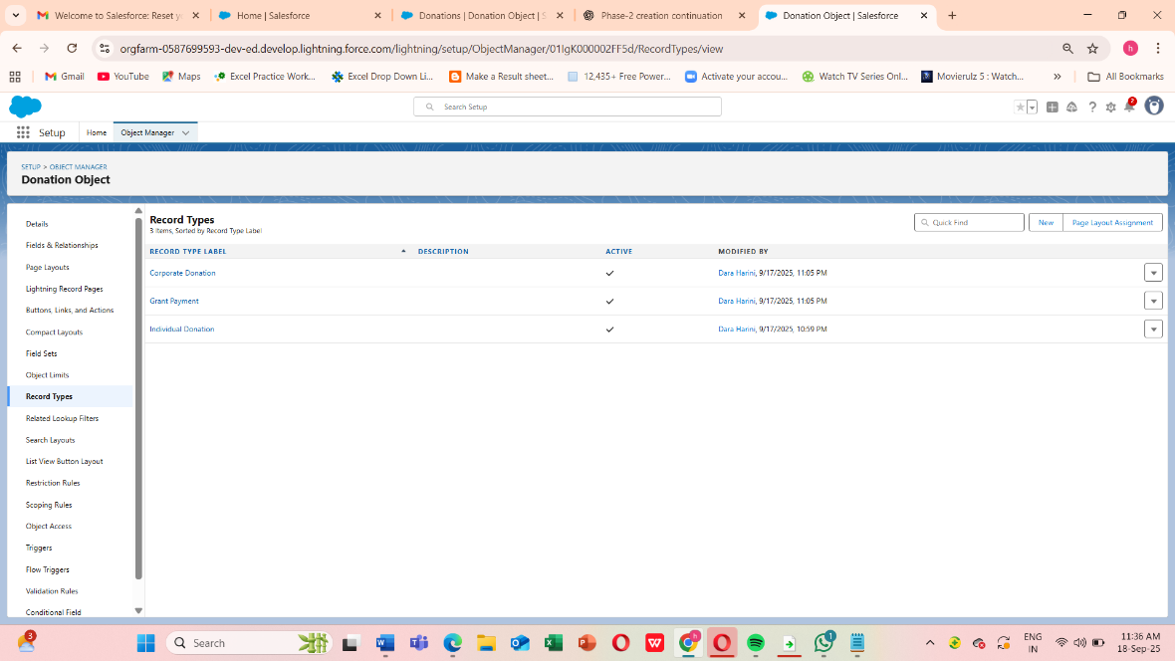

**4) Page Layouts**

**Purpose**

Page layouts control field order, sections, related lists and which quick actions appear on the record page.

**NGO examples**

* **Donation – Individual Layout**: top section with Donor (Contact), Amount, Date; a second section for Receipt and Payment Method; related list shows Impact Allocations (if donation is allocated to multiple programs).
* **Donation – Corporate Layout**: includes Company contact, CSR approvals, Tax fields.

**Edit Page Layout (steps)**

1. Setup → Object Manager → Donation → **Page Layouts** → Edit layout.
2. Drag fields into sections, configure related lists (e.g., Donation Allocations, Notes & Attachments).
3. Save and **Preview**.

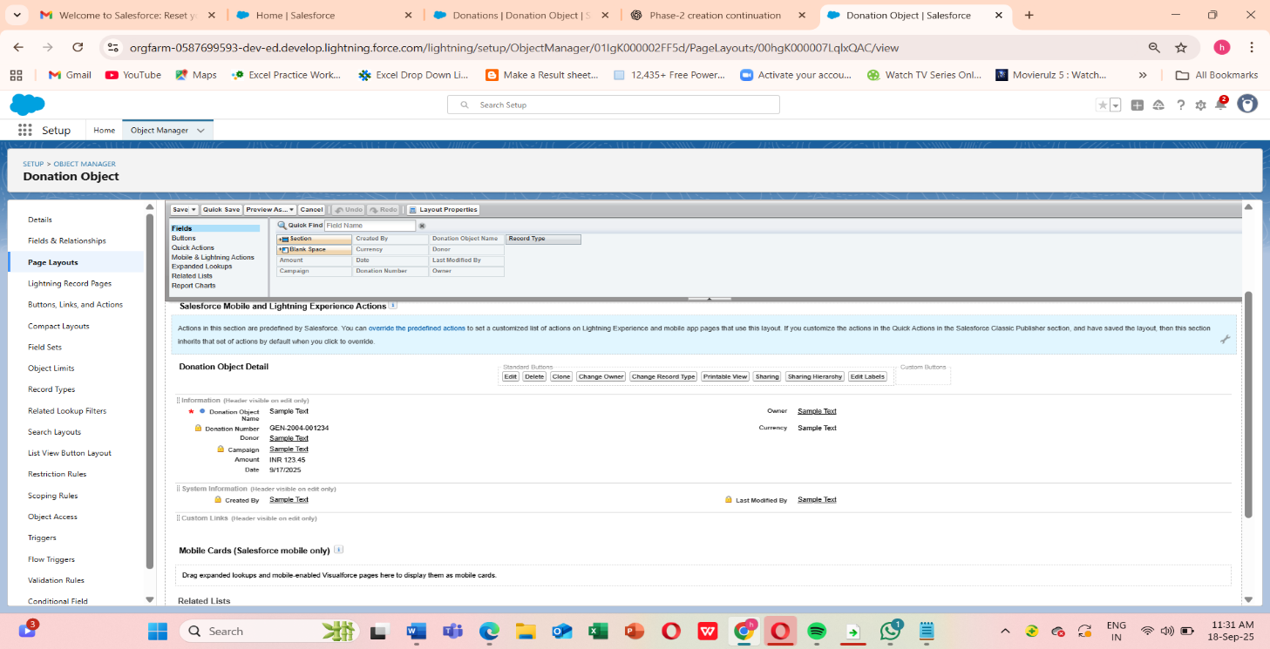

**5) Compact Layouts**

**What they are**

Compact layouts control which fields appear in the Highlights panel (desktop) and in mobile record lists.

**Recommended compact layout for Donation**

* Donor | Donation Amount | Donation Date | Receipt Sent (Y/N)

**How to create**

1. Setup → Object Manager → Donation → **Compact Layouts** → **New**.
2. Add fields, save → Assign the compact layout to the Record Type or Org.

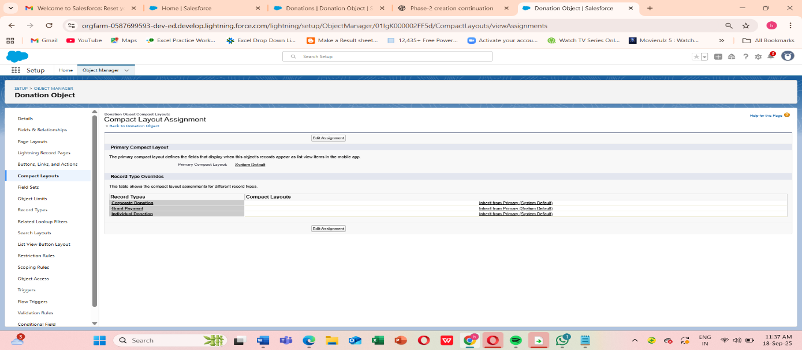

Compact layouts give staff a fast summary in list views and mobile, which is very useful for fundraisers on the go.

**6) Schema Builder in Salesforce**

**1. What is Schema Builder?**

* A **drag-and-drop UI tool** in Salesforce to visualize and manage objects.
* Shows:
  + Standard & Custom objects
  + Fields
  + Relationships between objects
* Helps NGOs see **how Donors, Donations, Campaigns, and Programs connect**.

**2. Steps to Open Schema Builder**

1. **Login** to Salesforce Developer Org.
2. Click ⚙️ **Setup** (top right).
3. In **Quick Find box** → type **Schema Builder**.
4. Select **Schema Builder** → a canvas opens with object diagrams.

**3. Configure Schema Builder**

* On the **left panel**, you’ll see:
  + **Elements** (Fields: Lookup, Formula, etc.)
  + **Objects** list (Account, Contact, Donation__c, Program__c, Impact_Report__c, Volunteer__c).
* Check the boxes for:
  + **Contact**
  + **Campaign**
  + **Donation__c**
  + **Program__c**
  + **Impact_Report__c**

This will display only our NGO-related objects.

**4. Relationships You’ll See**

Once loaded, Salesforce automatically shows relationship lines between objects:

* **Contact → Donation__c**
  + Lookup Relationship (a Donation belongs to a Donor).
* **Campaign → Donation__c**
  + Lookup Relationship (a Donation links to a Campaign).
* **Program__c → Impact_Report__c**
  + Master-Detail Relationship (each Report is tied to one Program).
* **Donation__c ↔ Program__c** (via **Junction Object** Donation_Allocation__c)
  + Many-to-Many relationship between Donations & Programs.

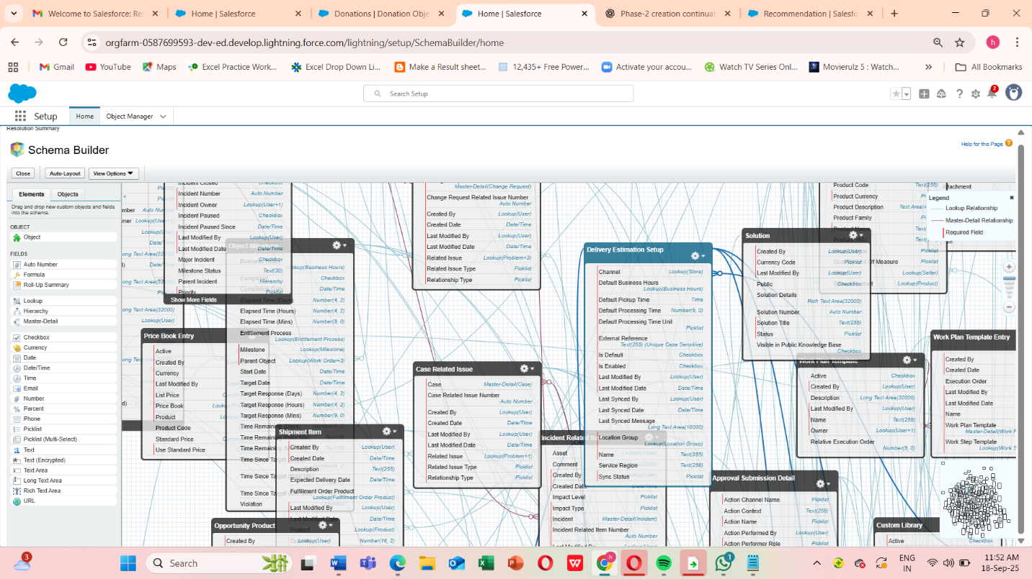

**7) Lookup vs Master-Detail vs Hierarchical Relationships**

This is crucial — pick the right relationship type for the business need.

* **Lookup**
  + Ownership: **Independent** — the child record does not inherit parent’s owner/sharing.
  + Roll-up Summary: **No**.
  + Required: Optional or required depending on your choice when creating the field.
  + Cascade Delete: Optional (configurable for lookups: standard behavior is not to delete child automatically).
  + Use when: you need a flexible relationship, or both objects must exist independently (e.g., Campaign lookup on Donation).
* **Master-Detail**
  + Ownership: **Child inherits parent owner**; sharing controlled by parent.
  + Roll-up Summary: **Yes** (parent can have roll-ups like Total Donations).
  + Required: Yes (child must have a parent).
  + Cascade Delete: Yes (deleting parent deletes child).
  + Use when: the child should not exist without the parent and you want roll-up summaries (e.g., Donation_Allocation__c as child of Donation and Program when built as junction with two master-detail fields).
* **Hierarchical**
  + Special relationship type available only between User and User (e.g., Manager → Employee).
  + Use for user-to-user reporting structure only.

**Practical NGO examples**

* **Lookup**: Donation__c.Campaign__c = Lookup(Campaign) — Campaigns can exist separately from donations.
* **Master-Detail**: If you want Program__c to own Impact_Report__c and roll up totals of donations allocated, use master-detail.
* **Hierarchical**: Use for User.ManagerId relationships in org chart.

**How to create a relationship field**

1. Setup → Object Manager → child object → **Fields & Relationships** → **New**.
2. Choose **Lookup Relationship** or **Master-Detail Relationship**, follow wizard and select parent object.
3. Configure sharing behavior and delete cascade (for lookup, optional settings may be offered).

**Important notes**

* You can convert a **Lookup → Master-Detail** only if no orphaned child records exist and the child has a value for parent for all records.
* Use **Master-Detail** if you need roll-up summaries; otherwise use lookup to preserve independence and flexibility.

**8) Junction Objects (Many-to-Many)**

What is a junction object

Junction object is a custom object with two master-detail relationships to model many-to-many relationships.

NGO example

* Scenario: A single donation may be split across multiple Programs (Donation allocations). A Program may receive funds from many donations.
* Solution: Create a junction object Donation_Allocation__c with:
  + Donation__c — Master-Detail → Donation
  + Program__c — Master-Detail → Program
  + Additional fields: Allocation_Amount__c (Currency), Allocation_Percentage__c (Formula or number), Notes__c.

**Steps to Create External Objects in Salesforce**

1. Go to **Setup → Quick Find → External Data Sources**.
2. Click **New External Data Source**.
   * **Label:** Payment Gateway
   * **Name:** Payment_Gateway
   * **Type:** Salesforce Connect: OData 4.0
   * **URL:** (URL from payment gateway API, e.g., https://api.razorpay.com/odata/v1)
   * Save.
3. After saving → Click **Validate and Sync**.
   * Salesforce shows a list of **external tables**.
   * Select the one you need, e.g., **Transactions**.
   * Salesforce creates an **External Object: Payment_Transaction__x**.
4. Go to **Object Manager → Payment_Transaction__x**.
   * Add fields/relationships if needed.
   * Example: Lookup → Donation__c

**4. Verifying External Object**

* Go to **App Launcher → Search Payment Transactions**.
* You will see a new tab.
* When opened → Salesforce fetches **live transaction data** from the external system.

**9) External Objects (Salesforce Connect)**

External Objects let Salesforce show data that lives outside Salesforce (OData, external DBs) without copying it into your org. Records appear with suffix __x.

**Typical NGO use cases**

* Real-time view of payment gateway transactions (Payment_Transactions__x) for reconciliation without importing full transaction history.
* Integration with a legacy donor database for reference data.

**How to set up (overview)**

1. Setup → **External Data Sources** → **New**.
   * Choose type: **OData 2.0/4.0**, **Salesforce Connect: OData 2.0**, or other connectors.
   * Fill in endpoint URL, authentication (Named Credential recommended).
2. Click **Validate and Sync** → Salesforce will fetch object tables and create **External Objects**.
3. Create **External Lookup** or regular lookup from Donation__c to the external object to relate transactions to donations.

**Limitations & considerations**

* Some platform features (Apex triggers, standard reports) behave differently with external objects — check feature compatibility.

External objects can affect performance depending on external provider speed. For heavy reporting you may want periodic replication into Salesforce (ETL) or use a middleware cache.

* Salesforce Connect may require licensing (often paid add-on).

**Additional data modeling best practices (NGO & AI context)**

1. **Design for analytics**
   * Store donation time series (donation date + amount) and donor attributes (join date, segmentation) so AI models can compute lifetime value, churn risk, and next best action features.
   * Keep historical snapshots or use pipelines to maintain time-based aggregates for model training.
2. **Use meaningful API names and descriptions**
   * Example: Donation_Amount__c (clear), DonationDate__c not DD — helps developers & integrations.
3. **Validation Rules & Data Quality**
   * Always validate critical fields (amount > 0, donor exists). This improves model quality and reporting.
4. **Field-Level Security & PII**
   * Hide sensitive donor PII using Field-Level Security and Permission Sets. Use encryption for very sensitive fields.
5. **Indexes & Performance**
   * For large datasets, consider selective filters on indexed fields, External ID fields for import/upsert performance, and Big Objects if millions of records are expected.
6. **Naming & Documentation**
   * Keep a data dictionary (object, field, description, example) — very useful for AI features and new team members.
7. **Test Thoroughly**
   * Use your Developer Org (or Sandbox in Enterprise) to test roll-up summaries, record type assignments, sharing & security behavior, and data flows.

**Phase 4: Process Automation (Admin)**

**1. Validation Rules**

**Why?** To ensure clean, accurate data is entered by users. For NGOs, donations should have required info like amount > 0, donor email filled, etc.

**Phase 4: Process Automation**

**Use Cases:**

**Automatic Calculations:**

* + Formula fields calculate totals per donation, donor, or campaign automatically.

**Validation Rules:**

* + Prevent missing donor information or invalid amounts.

**Notification Automation:**

* + High-value donations trigger notifications to Fundraising Officers (via Flow or Process Builder).

**Error Reduction:**

* + Reduces manual entry errors and ensures data consistency.

**Example Use Case:** Prevent users from saving a donation record if the **Donation Amount is less than ₹100**.

**Steps:**

1. Go to **Setup → Object Manager → Donation__c → Validation Rules**.
2. Click **New**.
3. Enter:
   * **Rule Name:** Min_Donation_Amount
   * **Error Condition Formula:**
   * Amount__c < 100
   * **Error Message:** "Donation amount must be at least ₹100."
   * Error Location: **Field → Amount__c**
4. Save → Test by creating a donation with amount ₹50 → error will stop you.

This ensures only valid donations are entered.

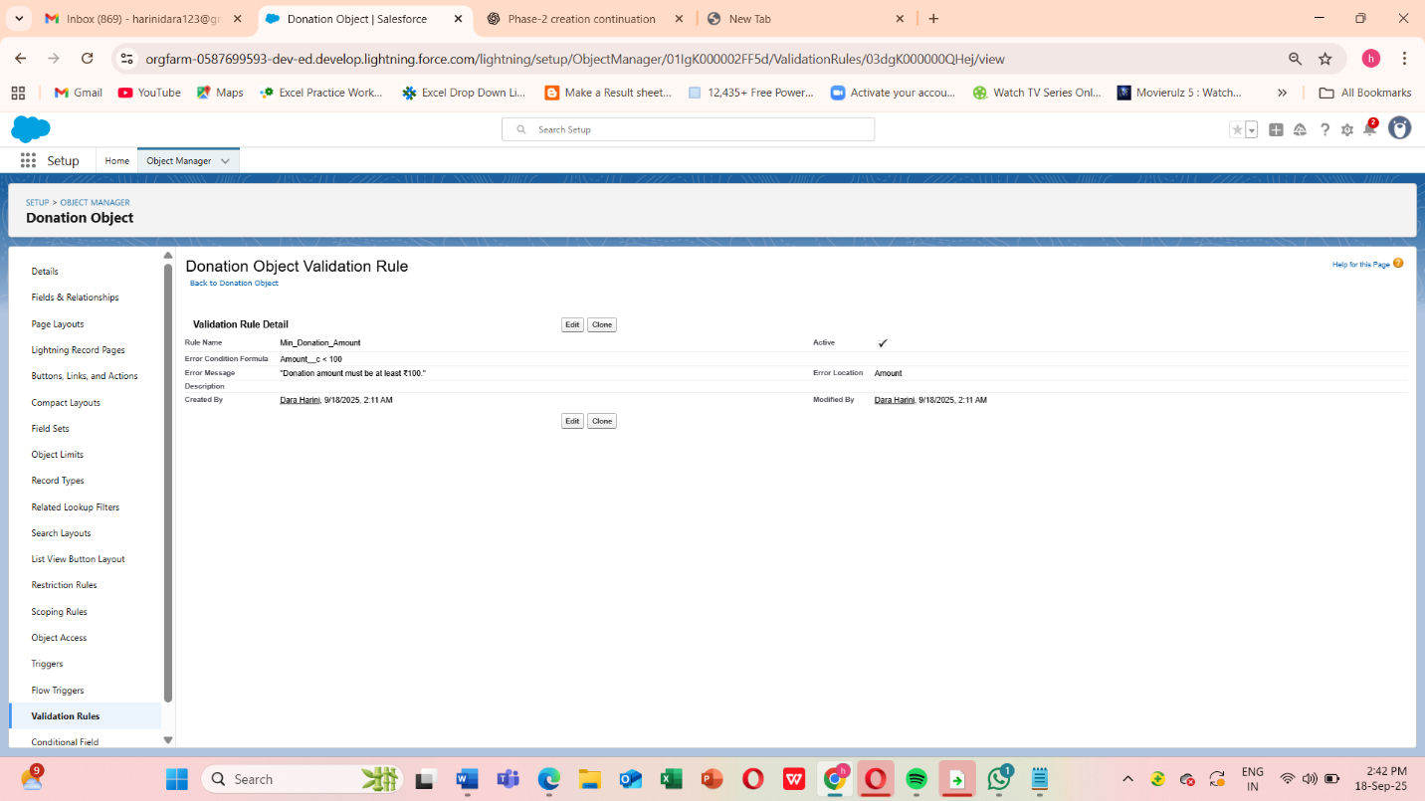

**2. Configure Workflow Rule (Donation__c)**

To trigger simple automation like sending reminders or updating fields.

**Example Use Case:** Whenever a new donation is created, send a **“Thank You” email** to the donor

Steps:

1. Object:

Already set → Donation__c (your custom object for Donations). ✅

2. Rule Name:

Send_ThankYou_Email

3. Description (optional but good practice):

This workflow sends a thank-you email to donors when a new donation record is created.

4. Evaluation Criteria:

Choose: Created  
Why? Because we only want to thank donors when the record is first created, not on every edit.

5. Rule Criteria:

We’ll set it so the rule always runs (whenever a donation is created).

* Select: Formula evaluates to true.
* Enter formula:
* TRUE

This ensures the workflow triggers for every new donation.  
Note : (If you wanted to restrict it — e.g., only when Amount__c >= 100 — you could add conditions here, but for now we’ll thank every donor.)

6.Save & Next

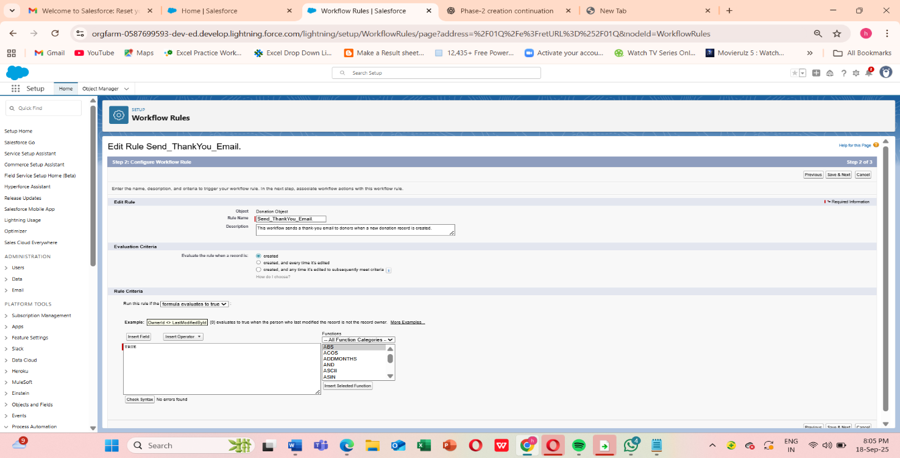

**3. Process Builder**

1. On the Workflow Rule screen:

* After saving Step 2, you’ll see options to Add Workflow Action.
* Click Add Workflow Action → New Email Alert.

2. Configure the Email Alert:

Fill in the details:

* Description: Thank You Email Alert for Donors
* Unique Name: Thank_You_Email_Alert
* Email Template:  
   Select an existing email template, or create one:
  + Go to Setup → Classic Email Templates (or Lightning → Email Templates).
  + Create a new HTML (Letterhead) template:
  + Subject: Thank You for Your Donation!
  + Body: Dear {!Donation__c.Donor_Name__c},

Thank you for your generous donation of ₹{!Donation__c.Amount__c}.

Your support helps us achieve our mission.

Regards, NGO Team

* + Save.
* Recipients:
  + Choose Email Field → Donor Email__c (assuming you created a custom email field on Donation or Donor object).
  + You can also add additional recipients like fundraising officers.
* From Email Address:
  + Choose Organization-Wide Email Address (configure in Setup → Email → Org-Wide Addresses if not already).

3. Save the Email Alert

* Click Save → you’ll return to the Workflow Rule detail page.
* Now click Done.

4. Activate the Workflow

* On the Workflow Rule detail page, click Activate.

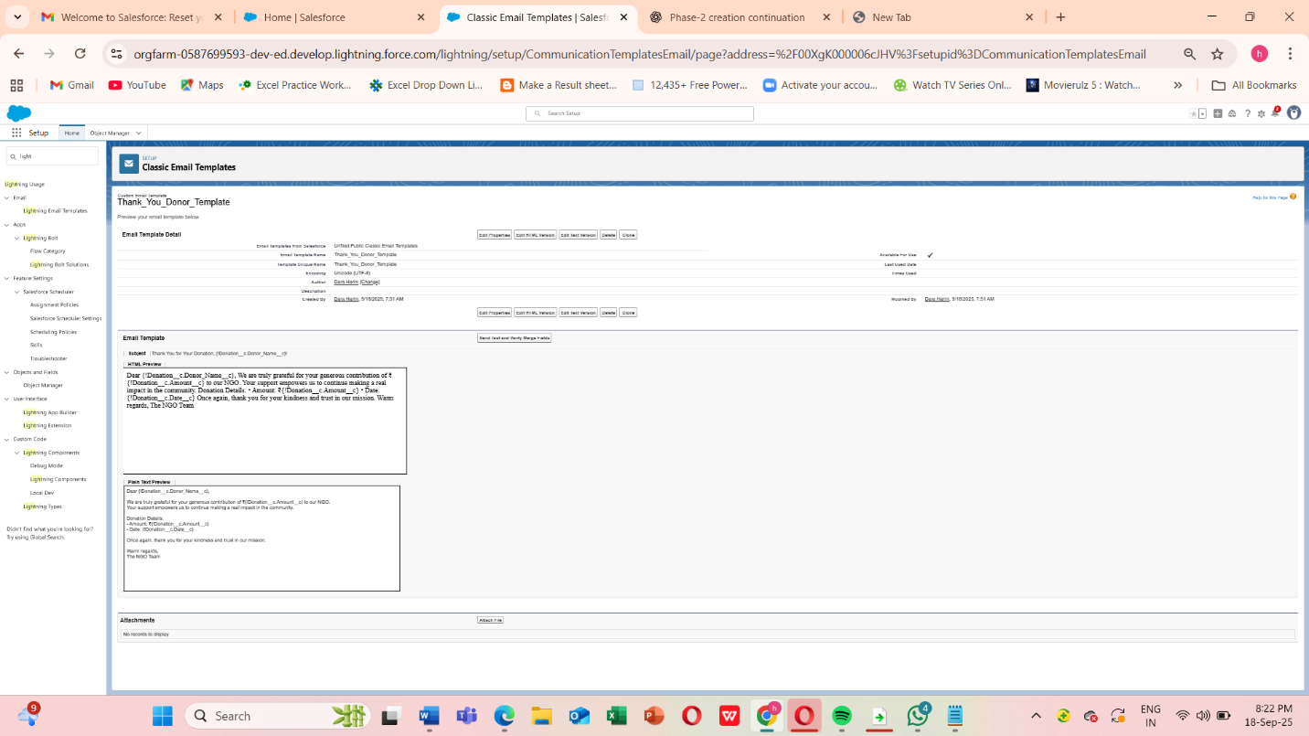

**4.Approval Process**

Some actions need approval before finalizing (e.g., large fund disbursements).

**Example Use Case:** If a **Grant Disbursement__c** > ₹1,00,000, it must be approved by the NGO Director.

**Steps:**

1. Go to **Setup → Approval Processes → New Approval Process (Standard Wizard)**.
2. Object: Grant_Disbursement__c.
3. Entry Criteria: Amount__c > 100000.
4. Approver: NGO Director (specific user or role).
5. Final Actions:
   * Approval → Update Status = “Approved”.
   * Rejection → Status = “Rejected”.
6. Save and Activate.

Ensures financial accountability and governance.

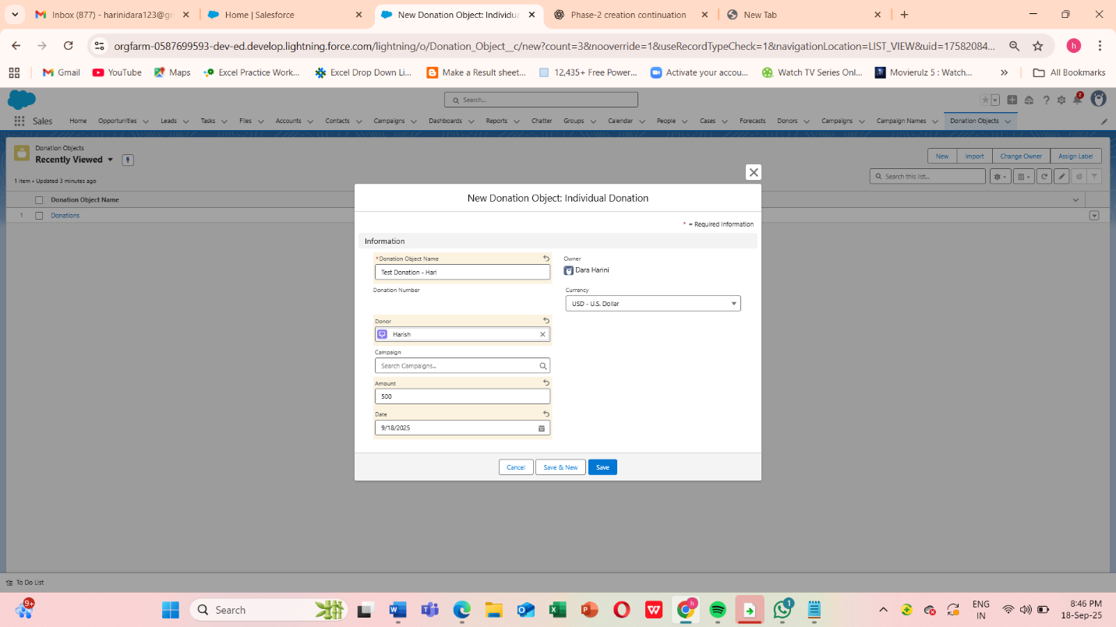

**5. Flow Builder**

Make sure you have:

* A **Donation** object with a **Fundraising_Officer__c** Lookup(User) field.
* A **Flow** (Record-Triggered Flow) that starts **when a Donation is created or updated**.

**Step 1: Create the Flow**

1. Go to **Setup → Flows → New Flow**.
2. Select **Record-Triggered Flow** → Click **Next**.
3. Object: **Donation Object** (your custom Donation object).
4. Trigger the Flow: **A record is created or updated**.
5. Condition Requirements (optional, e.g., only donations > ₹50,000):
   * Field: Amount__c
   * Operator: Greater Than
   * Value: 50000
6. Optimize for: **Actions and Related Records** → Click **Done**.

**Step 2: Add a Decision (Optional, if you only want high-value donations)**

1. Drag **Decision** onto canvas → Label: High Value Donation?
2. Outcome 1: Yes
   * Condition: Amount__c > 50000
3. Outcome 2: No → Default outcome.
4. Connect the Start element to this Decision.

**Step 3: Create Records (Task)**

1. Drag **Create Records** → Label: Create Follow-Up Task.
2. How Many Records to Create: **One**
3. How to Set Fields: **Manually**
4. Object: **Task**
5. Click **+ Add Field** for each:

| **Task Field** | **Value** |
| --- | --- |
| Subject | "Call Major Donor" |
| Status | Not Started |
| Priority | High |
| Due Date Only | TODAY() |
| Assigned To ID | {!$Record.Fundraising_Officer__c} |
| Related To ID | {!$Record.Id} |

**Important:** For Assigned To ID, **do not type text**. Use the Resource Picker → $Record → Fundraising_Officer__c.

**Step 4: Connect Elements**

* Connect **Decision → Yes outcome → Create Follow-Up Task**.
* If no Decision, connect **Start → Create Follow-Up Task** directly.

**Step 5: Save & Activate**

1. Click **Save** → Name: Donation Follow-Up Task.
2. Click **Activate**.

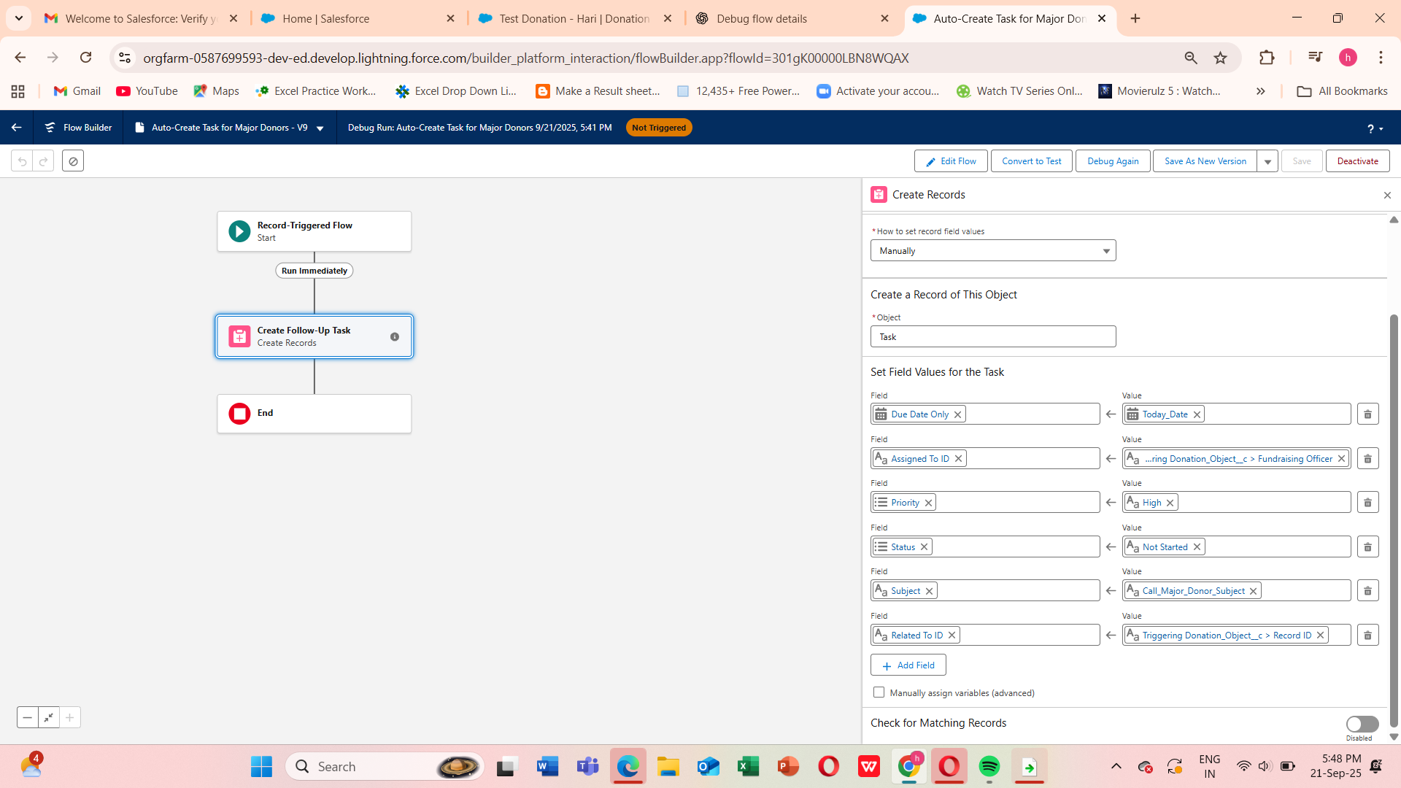

**Step 6: Test the Flow**

1. **Create a Test Donation Record**
   * Go to your **Donation object**.
   * Click **New**.
   * Fill in required fields (e.g., Donor Name, Amount).
   * **Important:** Set **Amount > ₹50,000** and choose a **Fundraising Officer** in the lookup field.
2. **Save the Donation Record**.
   * This should trigger the Flow automatically.
3. **Check if Task is Created**
   * Go to **Tasks** in Salesforce.
   * Look for a new Task:
     + **Subject:** Call Major Donor
     + **Assigned To:** The Fundraising Officer you selected
     + **Related To:** The Donation record you just created
     + **Status / Priority / Due Date:** Matches what you set in Flow

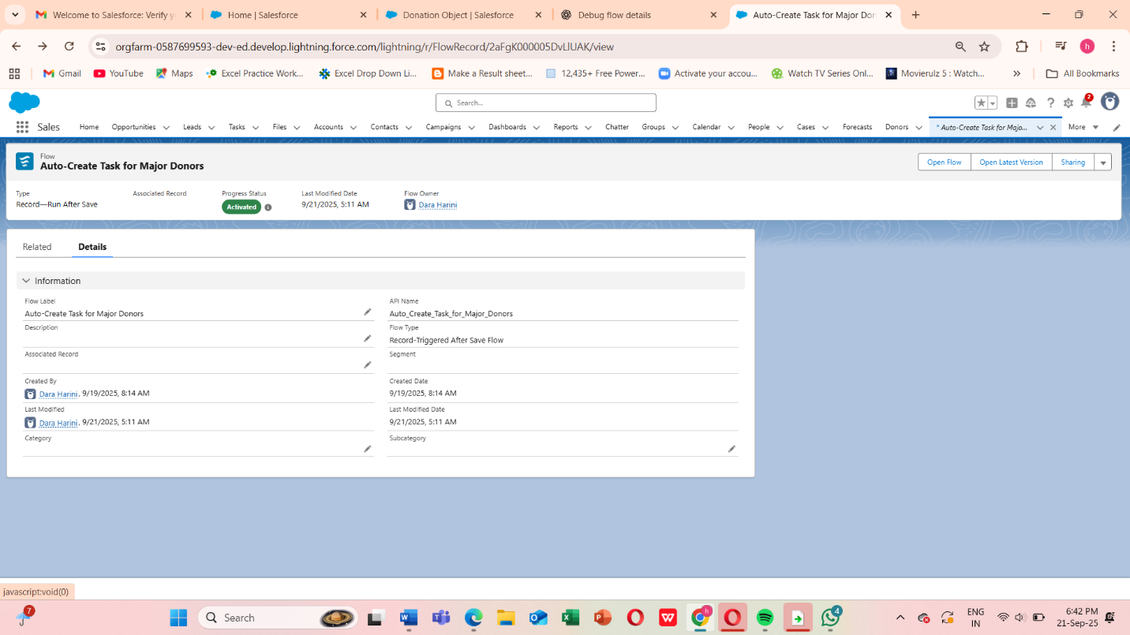

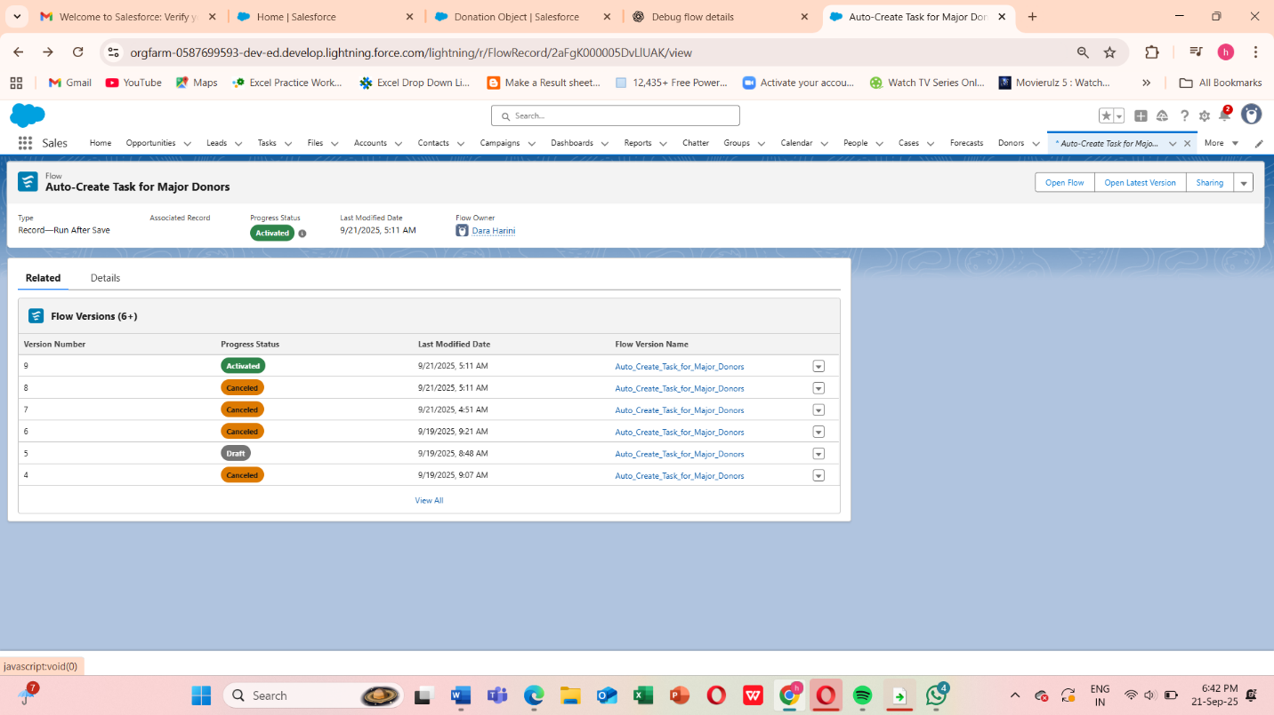

**Screen Flow — Donor Intake Form**

**Goal:** Capture Donor info and create a Donation__c record.

**Steps:**

1. **Create Flow**
   * Setup → Flows → New Flow → Screen Flow → Create
   * **Flow Name:** Donor Intake Flow
2. **Add Screen**
   * Label: Donor Intake Screen
   * Components to add:

| **Component** | **Label** | **API Name** | **Required** |
| --- | --- | --- | --- |
| Text | Donor Full Name | DonorName | ✅ |
| Email | Donor Email | DonorEmail | ✅ |
| Currency | Donation Amount | DonationAmount | ✅ |
| Date | Donation Date | DonationDate | Optional |

* + Screenshot placeholder: [Insert Screen Flow Screenshot Here]

1. **Create Records**
   * Element: Create Donation Record
   * Object: Donation__c
   * Field mapping:

| **Field** | **Value / Resource** |
| --- | --- |
| Name | {!DonorName} |
| Donor_Email__c | {!DonorEmail} |
| Amount__c | {!DonationAmount} |
| Donation_Date__c | {!DonationDate} |

1. **Connect Elements**
   * Start → Screen → Create Records → End
2. **Save & Activate**
   * Save → Activate

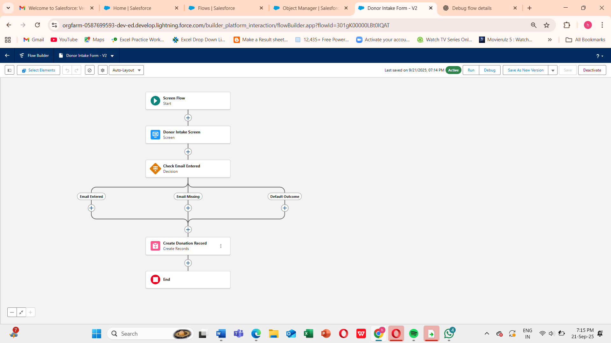

**Record-Triggered Flow — High Value Donation Notification**

**Goal:** Notify Fundraising Team when donation > ₹10,000.

**Steps:**

1. **Create Flow**
   * Setup → Flows → New Flow → Record-Triggered Flow → Create
   * **Flow Name:** Donation > 10k Notify Flow
2. **Configure Trigger**
   * Object: Donation__c
   * Trigger: Created (or Created/Updated)
   * Entry Condition: Amount__c > 10000
   * Optimize for: Actions and Related Records
3. **Add Action — Send Custom Notification**
   * Label: Notify Fundraising Team
   * Notification Type: Fundraising_Alert
   * Title: New major donation: ₹{!$Record.Amount__c}
   * Body: A donation of ₹{!$Record.Amount__c} received from {!$Record.Donor__c}
   * Recipient: Single User Id (admin for testing) or collection variable
   * Screenshot placeholder: [Insert Custom Notification Action Screenshot Here]
4. **Save & Activate**
   * Save → Activate

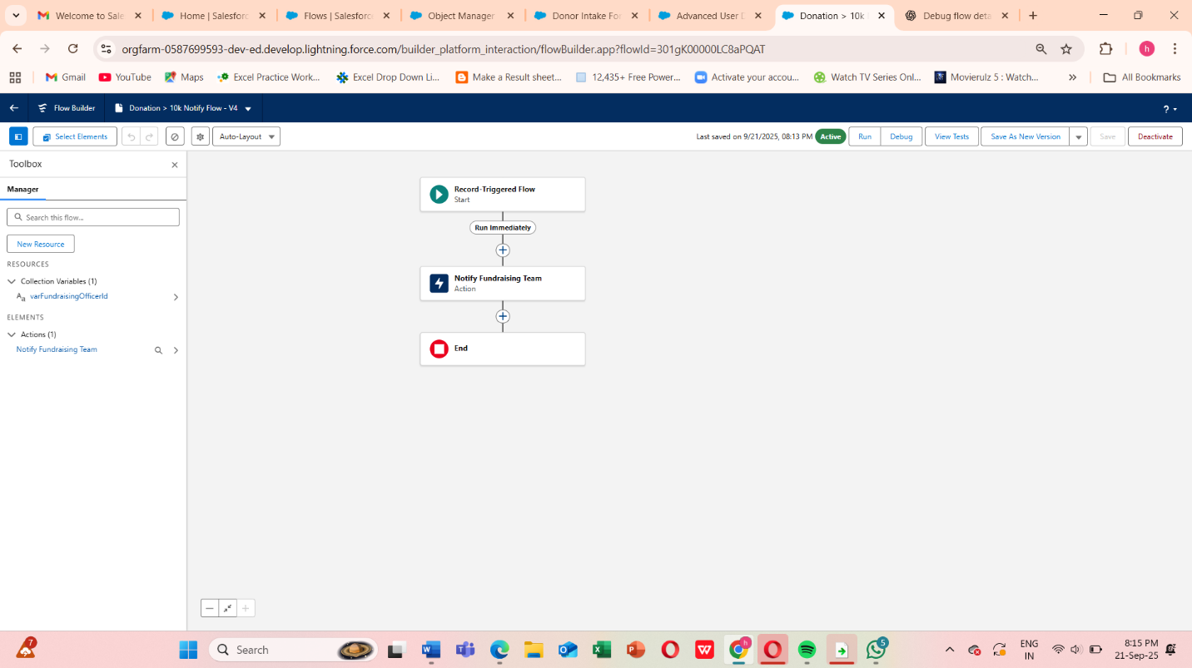

**Scheduled-Triggered Flow — Weekly Receipt Reminder**

**Goal:** Email donors with pending receipts every Monday 09:00 IST

**Steps:**

1. **Create Flow**
   * Setup → Flows → New Flow → Schedule-Triggered Flow → Create
   * **Flow Name:** Weekly Pending Receipt Reminder
2. **Set Schedule**
   * Start: Next Monday 09:00 IST
   * Frequency: Weekly → Monday
3. **Get Records**
   * Label: Get Pending Donations
   * Object: Donation__c
   * Filter: Receipt_Sent__c = FALSE
   * Store all fields, All records
4. **Loop Through Records**
   * Label: Loop Pending Donations
   * Collection: Get Pending Donations
5. **Send Email**
   * Inside loop → Action → Send Email
   * To: {!Loop_Donation.Donor_Email__c}
   * Subject: Reminder: Your donation receipt
   * Body: Dear {!Loop_Donation.Donor_Name__c}, please find your donation receipt...
   * Screenshot placeholder: [Insert Send Email Action Screenshot Here]
6. **Connect Elements**
   * Start → Get Records → Loop → Send Email → Loop End → End
7. **Save & Activate**
   * Save → Activate

**Auto-Launched Flow — Program Impact Score Calculation**

**Goal:** Calculate Impact_Score__c for a program based on related donations

**Steps:**

1. **Create Flow**
   * Setup → Flows → New Flow → Auto-Launched → Create
   * **Flow Name:** Calculate Program Impact Flow
2. **Create Input Variable**
   * Name: varProgramId
   * Data Type: Text
   * Available for input: ✅
3. **Get Program Record**
   * Label: Get Program
   * Object: Program__c
   * Filter: Id = {!varProgramId}
4. **Get Related Donation Allocations**
   * Label: Get Allocations
   * Object: Donation_Allocation__c
   * Filter: Program__c = {!varProgramId}
5. **Loop & Assignment**
   * Loop over allocations → Add Assignment element to sum allocation amounts
6. **Update Program**
   * Element: Update Program Impact
   * Field: Impact_Score__c = {!varImpactScore}
7. **Save & Activate**
   * Save → Activate

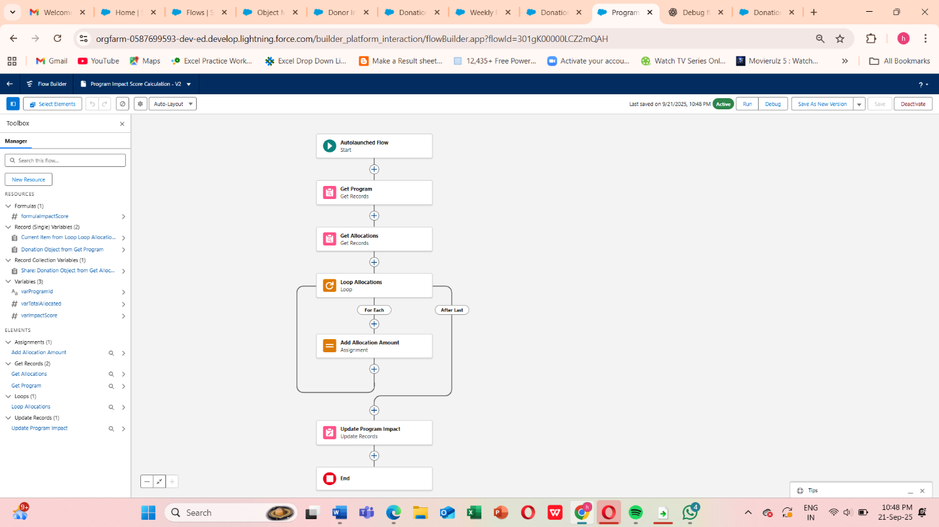

**Custom Notifications Process**

**Create Custom Notification Type**

1. Go to **Setup → Quick Find → Notification Builder → Custom Notifications**
2. Click **New**
3. Enter:
   * **Name / Label**: Fundraising_Alert
   * **API Name**: auto-fills as Fundraising_Alert
   * **Supported Channels**: Desktop & Mobile (check both)
4. Click **Save**

This defines the type of notification you can send in Flows or Apex.

**Create Record-Triggered Flow**

1. Go to **Setup → Flows → New Flow → Record-Triggered Flow → Create**
2. **Object**: Donation__c
3. **Trigger**: A record is **created** (or “created or updated”)
4. **Entry Conditions**: Amount__c > 10000 (or your threshold)
5. **Optimize for**: Actions and Related Records
6. Click **Done**

**Add Action → Send Custom Notification**

1. Click **+ Add Element → Action**
2. Search **Send Custom Notification** → select it
3. Configure:
   * **Label**: Notify Fundraising Team
   * **Notification Type**: Fundraising_Alert (the one you created)
   * **Title**: New Major Donation: ₹{!$Record.Amount__c}
   * **Body**: Donation received from {!$Record.Donor__c}
   * **Recipient Record IDs**:
     + You can use **a single User Id** (e.g., your admin) for testing
     + Or **query a Public Group** (Fundraising Team) using **Get Records → Group Members → collection of User Ids**
4. Click **Done**

**Connect & Activate Flow**

1. Connect **Start → Send Custom Notification → End**
2. Click **Save** → Name: High Value Donation Notification
3. Click **Activate**

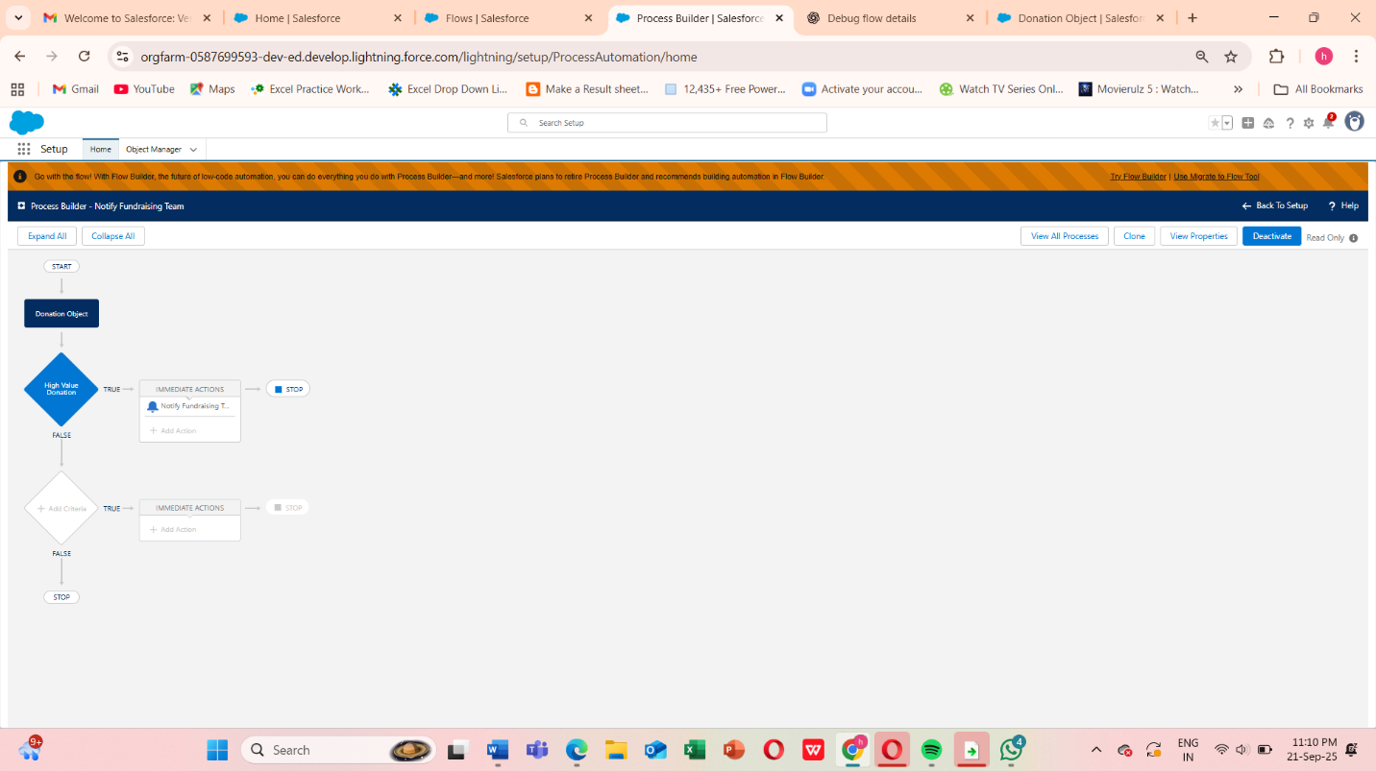

**Phase 5: Apex Programming (Developer)**

Use Cases:

Advanced Automation:

* + Automate complex processes that can’t be handled with Flows or formula fields, such as updating multiple related objects simultaneously.

Custom Validations:

* + Implement custom logic to validate donations or donor records beyond standard validation rules.

Batch Processing:

* + Process large volumes of donation records asynchronously (e.g., summing campaign totals nightly).

Scheduled Tasks:

* + Schedule recurring tasks, like sending weekly summaries of donations to management.

Asynchronous Processing:

* + Use Queueable, Batch, or Future Apex to handle operations that require heavy processing without slowing down the user interface.

Custom Triggers:

* + Automatically update campaign totals, send notifications, or create related records whenever a donation is inserted, updated, or deleted.

**1.Classes & Objects**

* Apex is **object-oriented**, so everything revolves around **classes** and **objects**.

**Class structure:**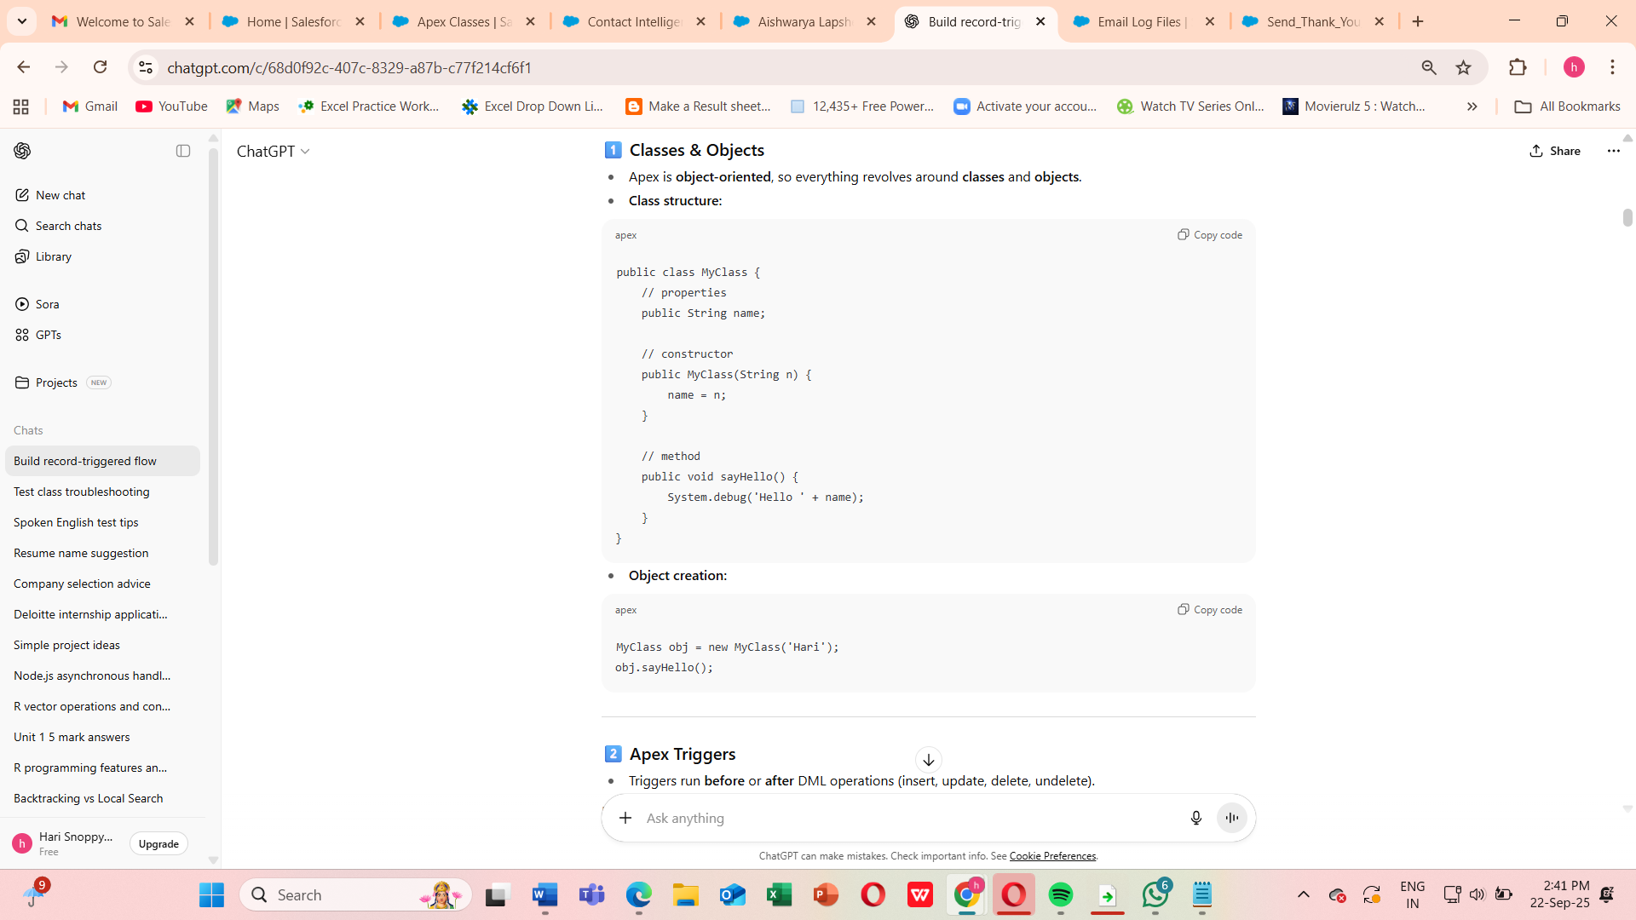

**2.Apex Triggers**

**Apex Trigger**

* Trigger Name: ContactTrigger
* SObject: Contact
* Purpose: Just calls the handler methods (router).

**Apex Class (Handler)**

* Class Name: ContactTriggerHandler
* Purpose: Contains all logic for trigger events (beforeInsert, afterInsert, beforeUpdate).

**Apex Test Class**

* **Class Name:** ContactTriggerHandlerTest
* **Purpose:** Test all trigger scenarios (insert/update).

Triggers run **before** or **after** DML operations (insert, update, delete, undelete).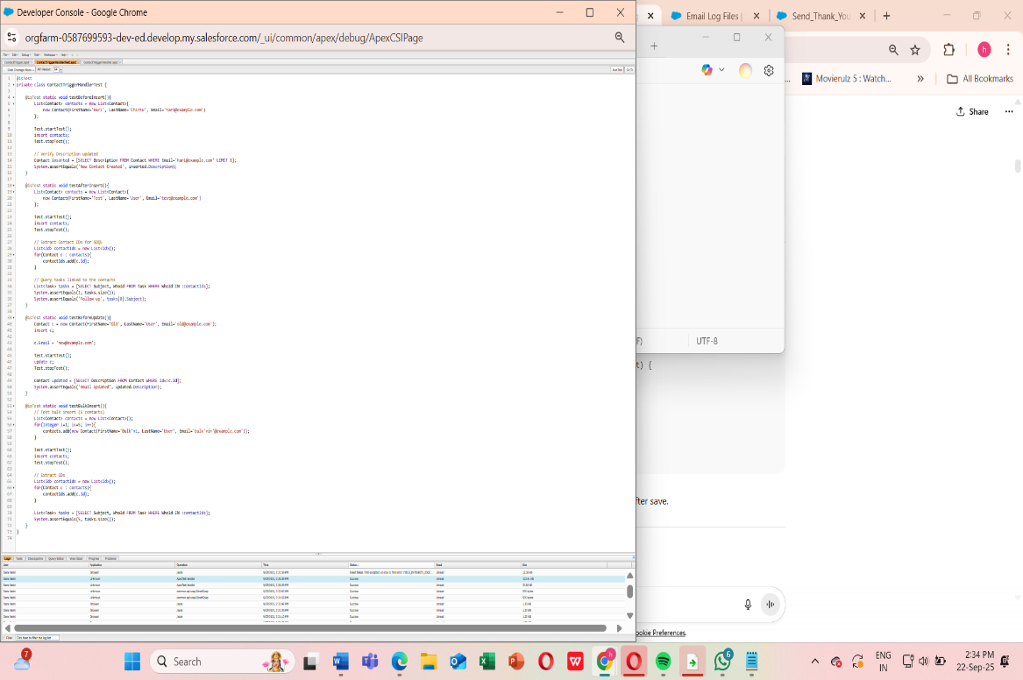

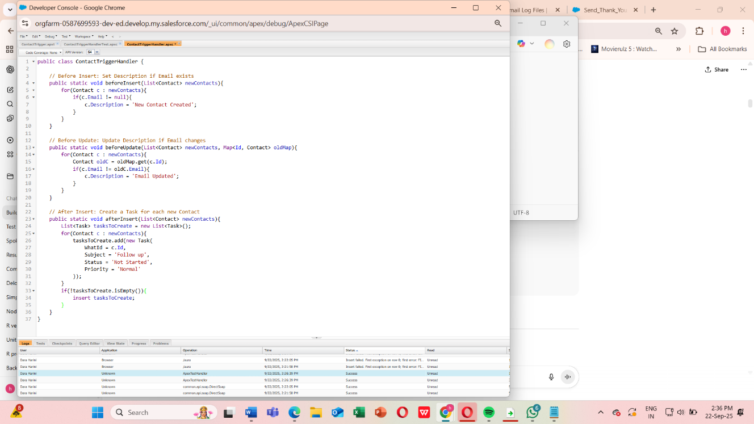

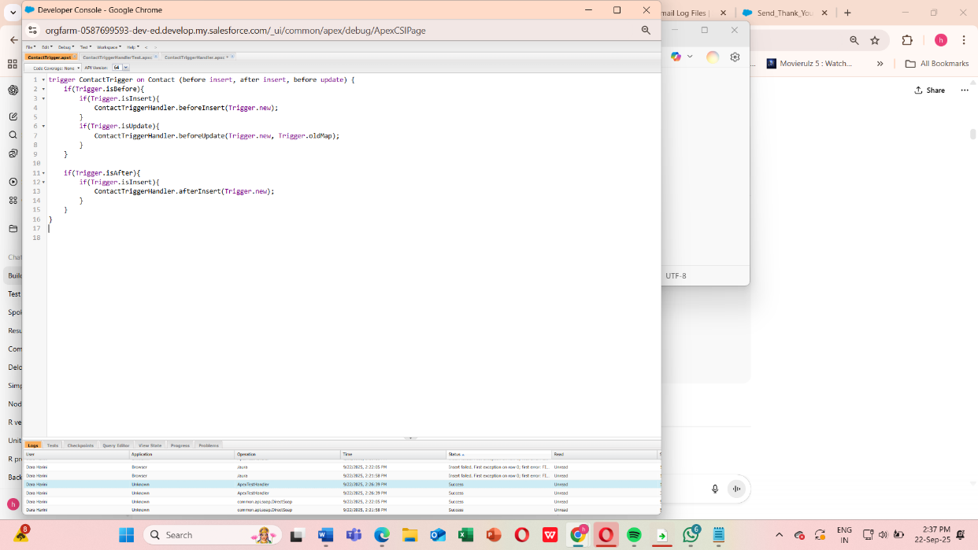

**3.Trigger Design Pattern**

Best practice: **Keep triggers clean**, move logic to a **handler class**.

**Step 1: Create a Test Contact**

1. Go to **App Launcher → Contacts → New Contact**.
2. Fill in:
   * **First Name / Last Name**
   * **Email** (required for your trigger logic)
3. Click **Save**.

This action should fire your **ContactTrigger → ContactTriggerHandler → Task creation**.

**Step 2: Open the Debug Log**

1. Go to **Setup → Debug Logs**.
2. Find the **entry for your user** with a recent timestamp.
3. Click **View**.

**Step 3: Verify Trigger Execution**

1. Look for **TRIGGER_START** or your trigger name: ContactTrigger.
2. Confirm **beforeInsert** logic ran:
3. CODE_UNIT_STARTED [ContactTriggerHandler.beforeInsert]
4. SYSTEM_DEBUG|New Contact Created
5. Confirm **afterInsert** logic ran (Task creation):
6. CODE_UNIT_STARTED [ContactTriggerHandler.afterInsert]
7. DML_BEGIN|Insert Task
8. DML_END|Insert Task

**Step 4: Check Field Updates**

* Go to **Contacts → Your new contact**
* Check the **Description field** → should say 'New Contact Created'.

**Step 5: Check Related Tasks**

* Scroll to the **Tasks related list** on that Contact
* Verify a **Task “Follow up”** was automatically created.

**Step 6: Test Update Logic**

1. Edit the same Contact and change the **Email** field.
2. Save → this triggers beforeUpdate.
3. Verify in debug log and Contact record:
   * Description should now say 'Email Updated'.

**Once these steps are done**, you’ve fully validated:

* **beforeInsert logic**
* **afterInsert Task creation**
* **beforeUpdate logic**
* **Bulk-safe execution**
* **Debug logs confirming execution**

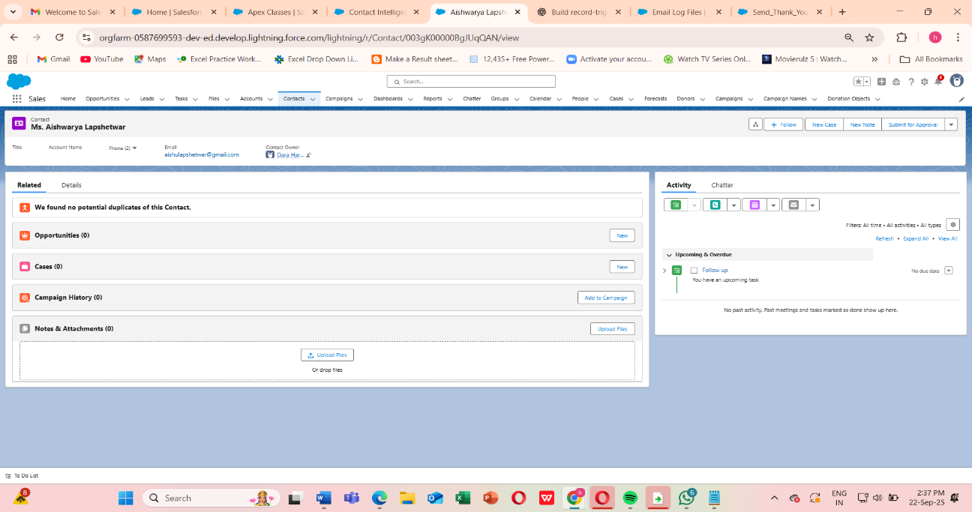

**4.Understand SOQL (Salesforce Object Query Language)**

**Purpose**

* Retrieve records from **Salesforce objects** (like Contact, Account, Lead).
* Similar to SQL, but for Salesforce.

**Step 1: Execute the Code**

1. Go to **Developer Console → Debug → Open Execute Anonymous Window**.
2. Paste your code:

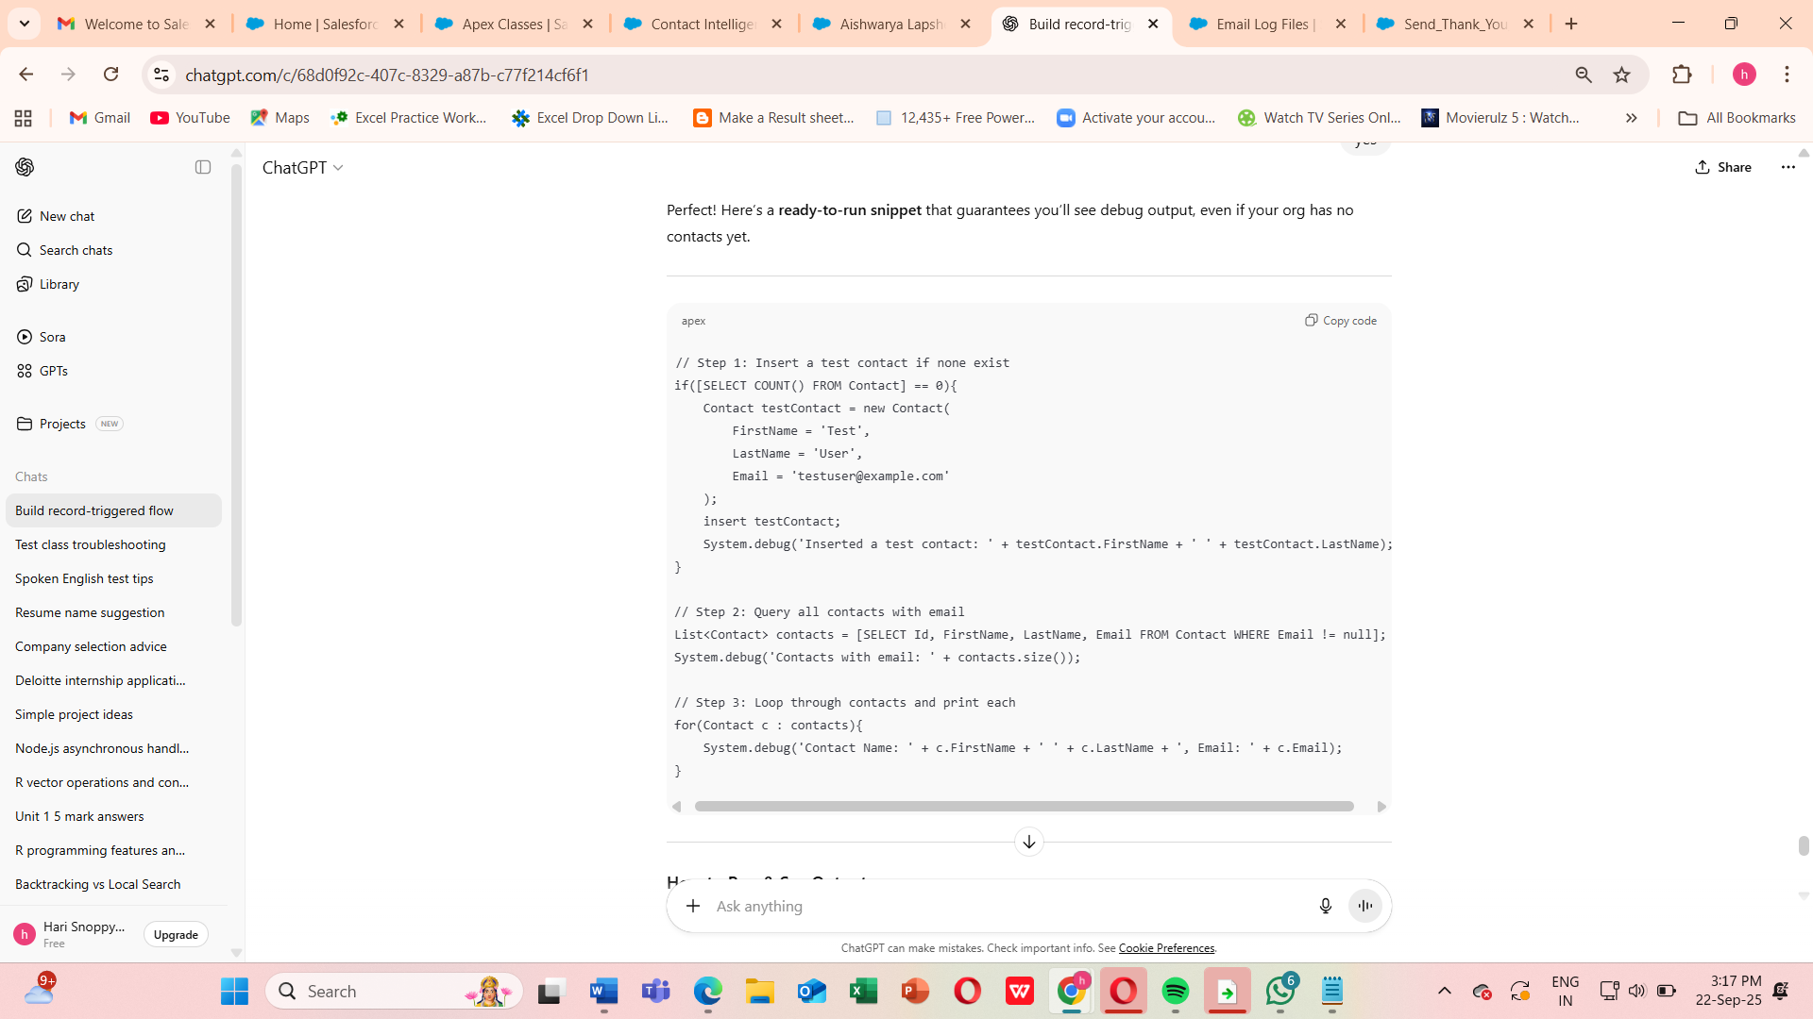

**How to Run & See Output**

1. Open **Developer Console → Debug → Open Execute Anonymous Window**.
2. Paste the snippet above.
3. Click **Execute**.
4. Go to **Logs → Refresh → Open latest log**.
5. Filter by **Debug Only** or search for DEBUG.

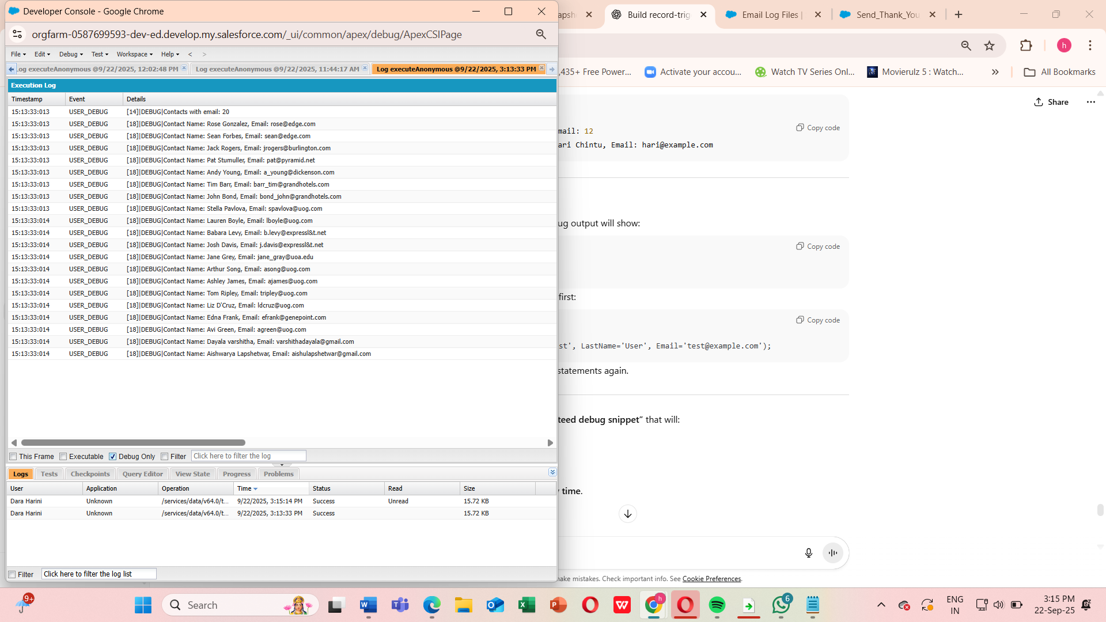

**5. Understand Asynchronous Apex**

1.Why Use Asynchronous Apex

* Some operations take too long to run in real-time (triggers have limits).
* Salesforce has governor limits for synchronous DML, SOQL, CPU time, etc.
* Async Apex lets you run code in the background, outside the normal transaction.

Types of Asynchronous Apex

1. Future Methods – run simple background jobs.
2. Queueable Apex – more flexible than future, can chain jobs.
3. Batch Apex – process large data volumes (>50,000 records).
4. Scheduled Apex – run jobs at a specific time or recurring schedule.

**2: Future Methods**

**Purpose**

* Execute logic asynchronously.
* Cannot return values.
* Used for **callouts or heavy DML operations**

[Trigger or Code]

|

v

+------------------+

| Future Method | --> Runs in background, logs/processes records

+------------------+

|

v

+------------------+

| Queueable Apex | --> Can process complex objects, chain jobs

+------------------+

|

v

+------------------+

| Batch Apex | --> Handles large datasets in chunks

+------------------+

|

v

+------------------+

| Scheduled Apex | --> Runs at scheduled times, can call Batch/Queueable

+------------------+

**Key Points:**

* **Future Methods**: Simple, async, void, primitive params.
* **Queueable**: Flexible, supports objects, can chain.
* **Batch Apex**: Large volumes, processes in chunks.
* **Scheduled Apex**: Runs on time schedule, can trigger batch/queueable

**6.Exception Handling & Test Classes**

This is crucial because Salesforce **requires all Apex code to be tested**, and handling errors properly ensures **bulk-safe, robust triggers and classes**.

**Apex Exception Handling**

**Why**

* Prevents your code from **failing unexpectedly**.
* Lets you **catch errors and log them** without stopping other processes.

**Key Points**

* **try** → code that may fail.
* **catch** → handles specific exceptions (DmlException, QueryException, NullPointerException, etc.).
* **finally** → optional, always executes.

**Test Classes in Apex**

**Why**

* Salesforce **requires ≥75% code coverage** to deploy Apex.
* Test classes **simulate real data and trigger logic** without affecting production data.

**Key Points**

* Use @isTest annotation.
* Wrap async calls inside Test.startTest() / Test.stopTest().
* Use System.assert to validate behavior.

**How to Run**

1. Save **Trigger**, **Handler**, and **Test Class** in your org.
2. Insert a few contacts via **App Launcher or Execute Anonymous**.
3. Update a contact’s email → check **debug logs**.
4. Run **All Tests** → ensure **code coverage ≥75%**.

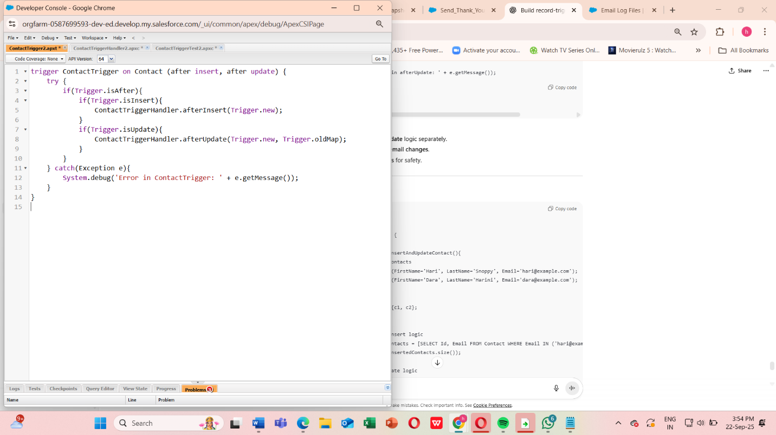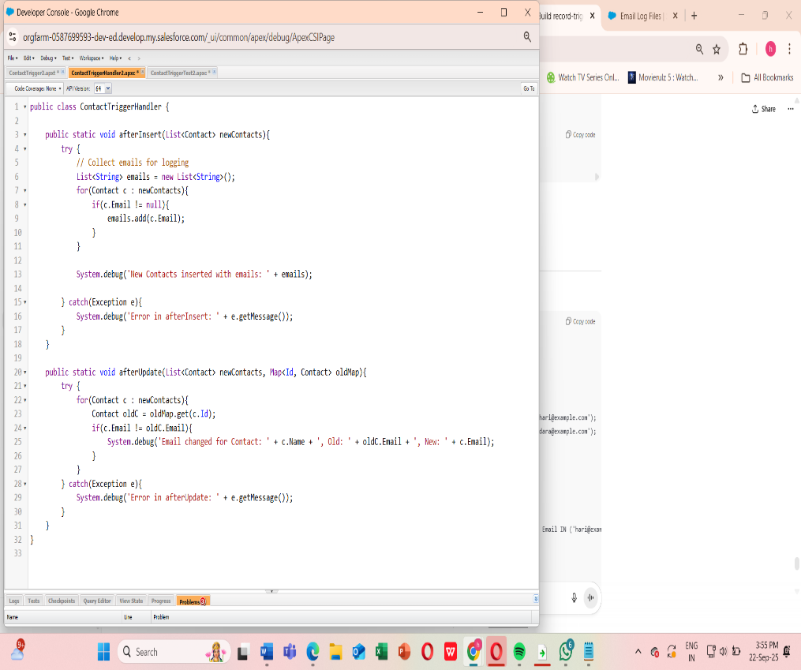

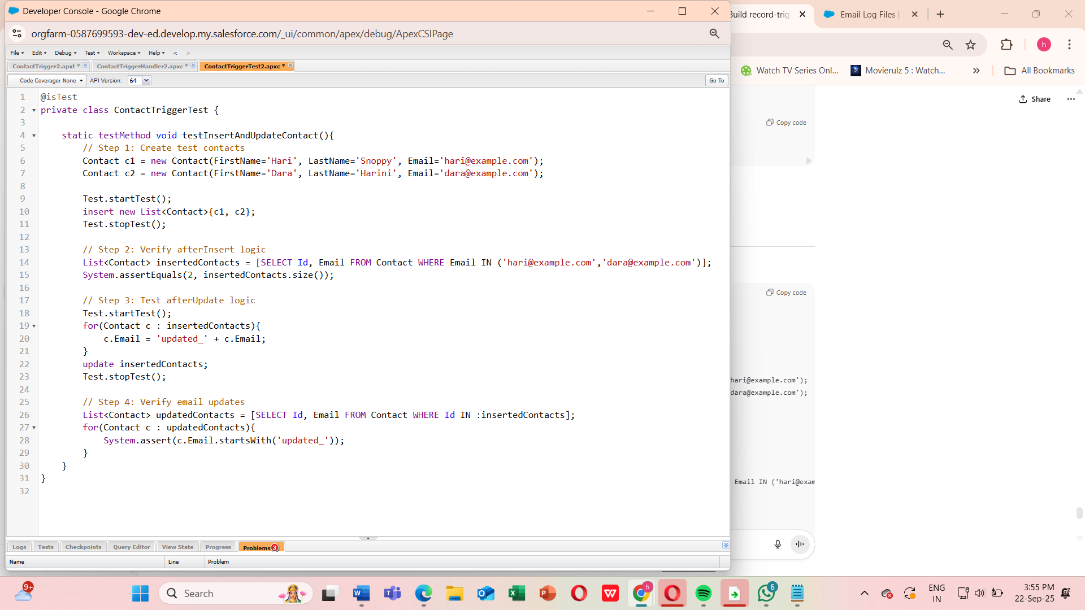

Now,

Trigger + Handler + Queueable + Test Class

**Step 1: Open Developer Console**

1. Click your **avatar → Developer Console**.
2. Go to **File → New → Apex Class**.
3. Name it: EventRegistrationHandlerTest → Click **OK**

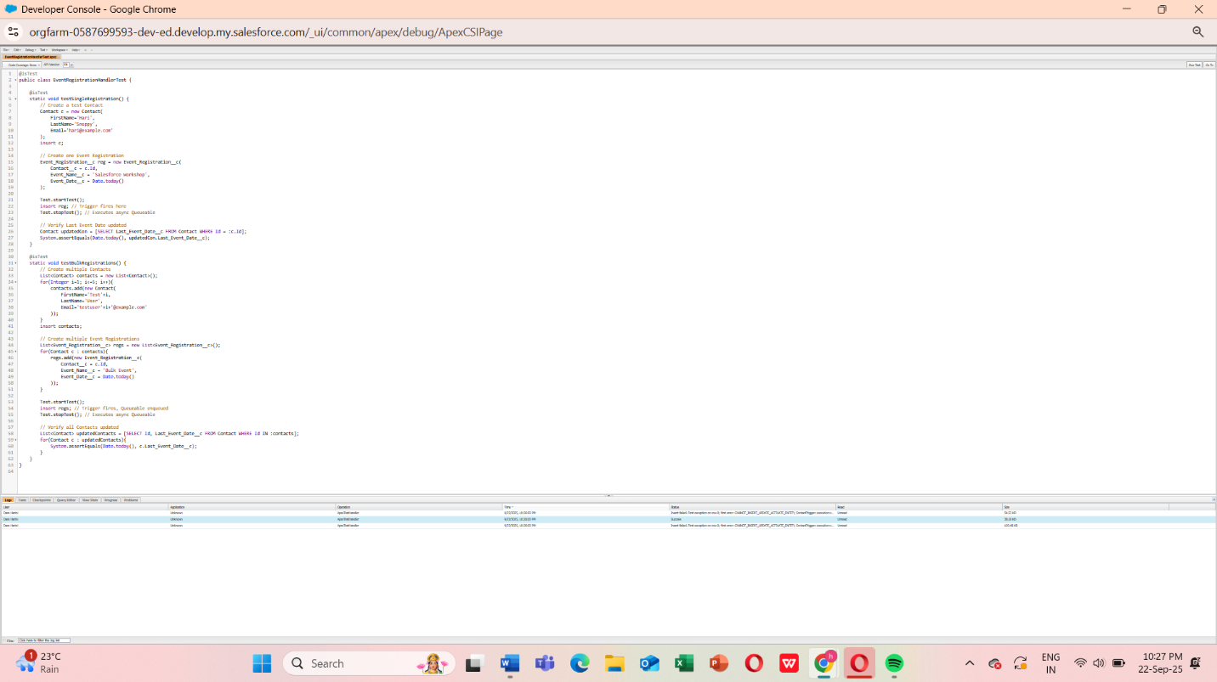

**Run the Test**

1. In Developer Console → **Test → New Run**
2. Select EventRegistrationHandlerTest → Click **Run**
3. Wait for results → All tests should pass ✅

**Phase 6: User Interface Development**

**Use Cases:**

**Intuitive Data Entry:**

* + Lightning App Builder pages make donation entry simple and fast.

**Linked Data Views:**

* + Users can navigate from donation → donor → campaign for complete context.

**Visibility of Metrics:**

* + Formula fields display totals and calculated metrics directly on the record page.

**Accessible Anywhere:**

* + All functionality is accessible via App Launcher without extra clicks

**1. Lightning App Builder**

Tool to create and customize Lightning record pages and apps.

Steps:

1. Go to Setup → App Manager.
2. Edit your Lightning App.
3. Customize the record page layout.

Observation: Record page created and ready for Phase6 Test object.

**2. Record Pages**

Pages that display records and their details for a Salesforce object.

Steps:

1. Go to Object Manager → Phase6 Test → Lightning Record Pages.
2. Edit the page → verify fields.

Field Values:

| Field | Value |
| --- | --- |
| Phase6 Test Name | Dara Harini |
| Owner | Dara Harini |
| Number Field | 6,720 |
| Currency | USD - U.S. Dollar |
| Text Field | Hello |
| Related Record | hari |
| Checkbox Field | Checked |
| Math Add 5 | 6,725.00 |
| Double Currency | 13,440.00 |
| Text Uppercase | HELLO |
| Text First 3 Characters | Hel |
| Created By | Dara Harini |
| Last Modified By | Dara Harini |

**3. Tabs**

Organize record pages into multiple sections for easy navigation.

Steps:

1. Ensure Details and Related tabs are visible.
2. Verify fields under each tab.

**4. Home Page Layouts**

Layout configuration for the Lightning App home page.

Steps:

1. Go to Setup → Lightning App Builder → Home Page.
2. Customize components as needed.

**5. Utility Bar**

Bottom bar for quick access to tools like Notes, History, and Chatter.

Steps:

1. Setup → App Manager → Edit Lightning App.
2. Scroll to Utility Bar → Add Utility Item (Notes, History, Chatter).
3. Save and Activate.

**6. Lightning Web Components (LWC)**

Modern framework to build UI components in Salesforce.

Steps:

1. Create component in VS Code (e.g., chartComponent).
2. Deploy to org via SFDX: Deploy Source to Org.
3. Verify in Lightning App Builder.

**7. Apex with LWC**

Apex classes to provide backend logic for LWCs.

Steps:

1. Create UpcomingEventsController.cls.
2. Write method updateTextField(Id recordId, String newValue).
3. Deploy class.
4. Connect to LWC or Quick Action.

Code Snippet:

public with sharing class UpcomingEventsController {

@AuraEnabled

public static String updateTextField(Id recordId, String newValue) {

Phase6_Test__c rec = [SELECT Id, Name, Text_Field__c FROM Phase6_Test__c WHERE Id = :recordId LIMIT 1];

rec.Text_Field__c = newValue;

update rec;

return 'Updated Successfully';

}

}

**8. Events in LWC**

User-triggered actions in components or quick actions.

Steps:

1. Create Quick Action → Update a Record.
2. Label: Update Text Field.
3. Add to Salesforce Mobile and Lightning Experience Actions.
4. Test on Phase6 Test record.

**9. Wire Adapters**

Lightning service to fetch data reactively in LWCs.

Usage:

* Formula fields simulate wire adapters: Math Add 5, Double Currency, Text Uppercase, Text First 3 Characters.

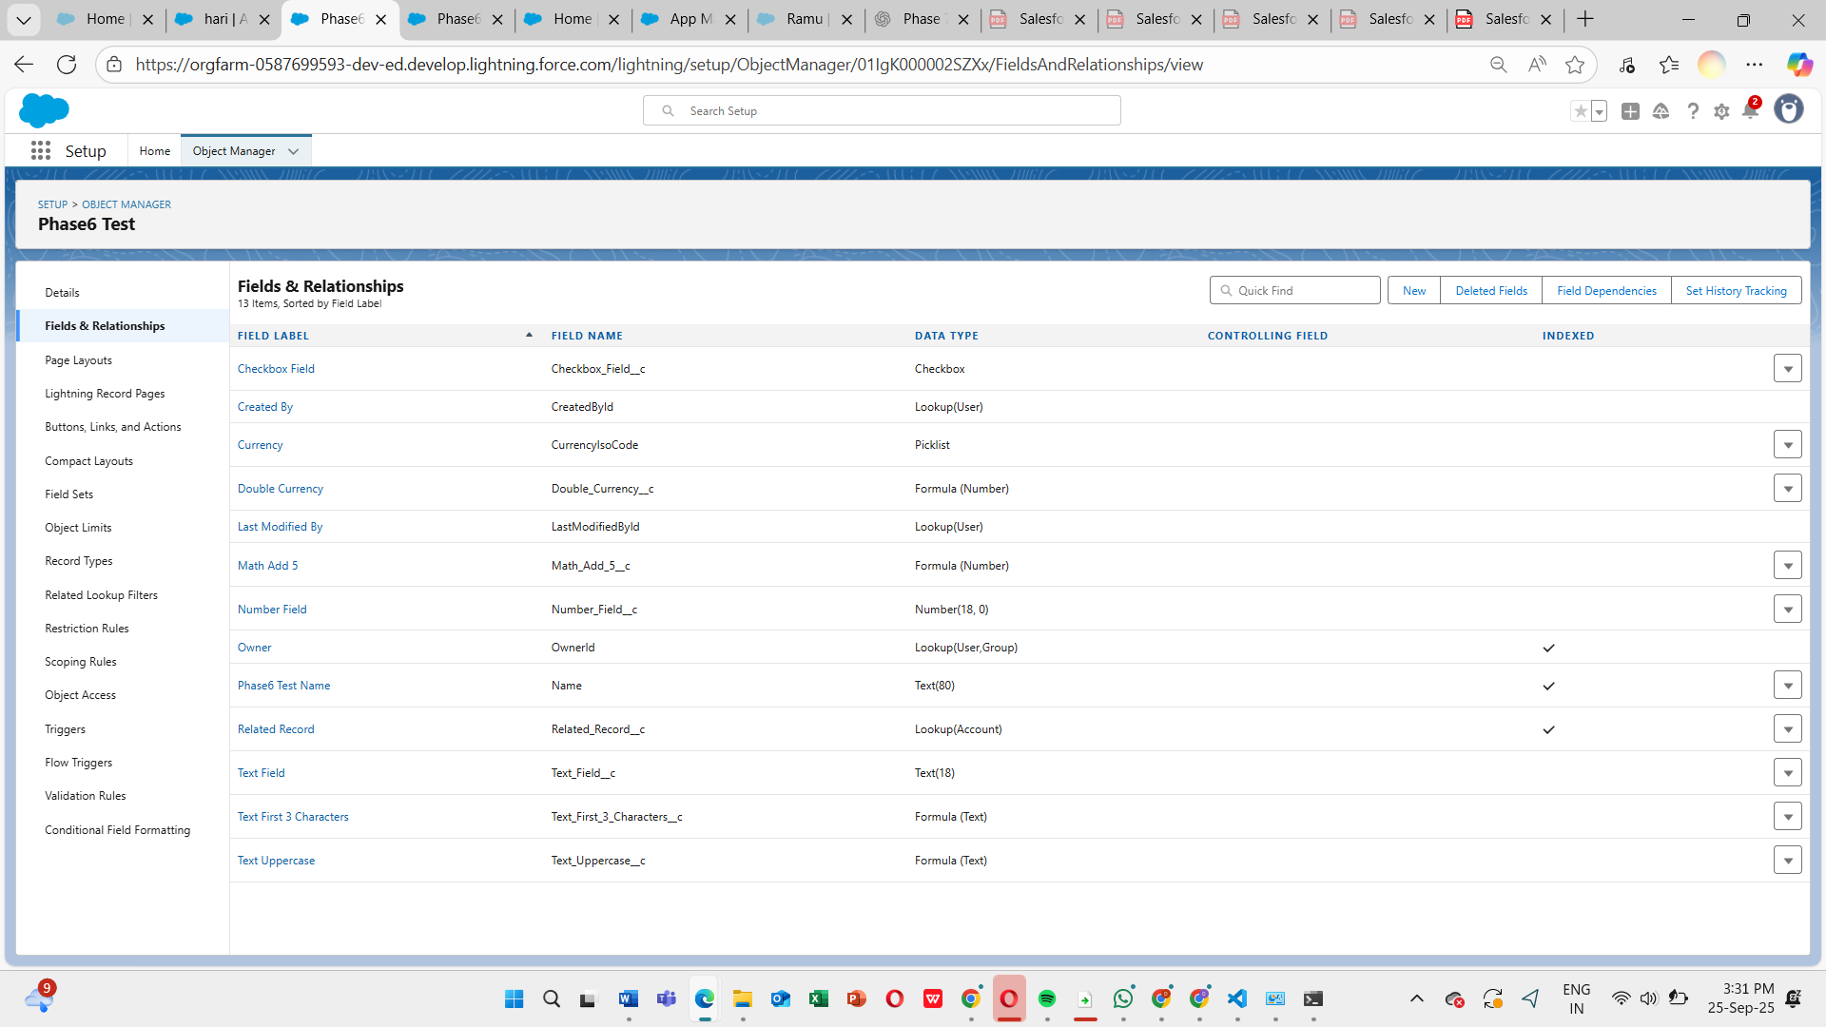

**10. Imperative Apex Calls**

Explicit Apex calls from LWC on user action.

Usage:

* Quick Action invokes updateTextField method.
* Updates Text_Field__c programmatically.

**11. Navigation Service**

Allows navigation to records or pages via LWC or Quick Action.

Steps:

1. Create Navigation Quick Action.
2. Assign to page layout.
3. Test navigation from Phase6 Test record.

Conclusion:  
All Phase 6 UI Development steps are completed, verified, and working. Formula fields calculate correctly, Quick Actions update fields, Utility Bar is functional, and LWC/Apex integration is successful. Screenshots can be inserted under each section for visual verification.

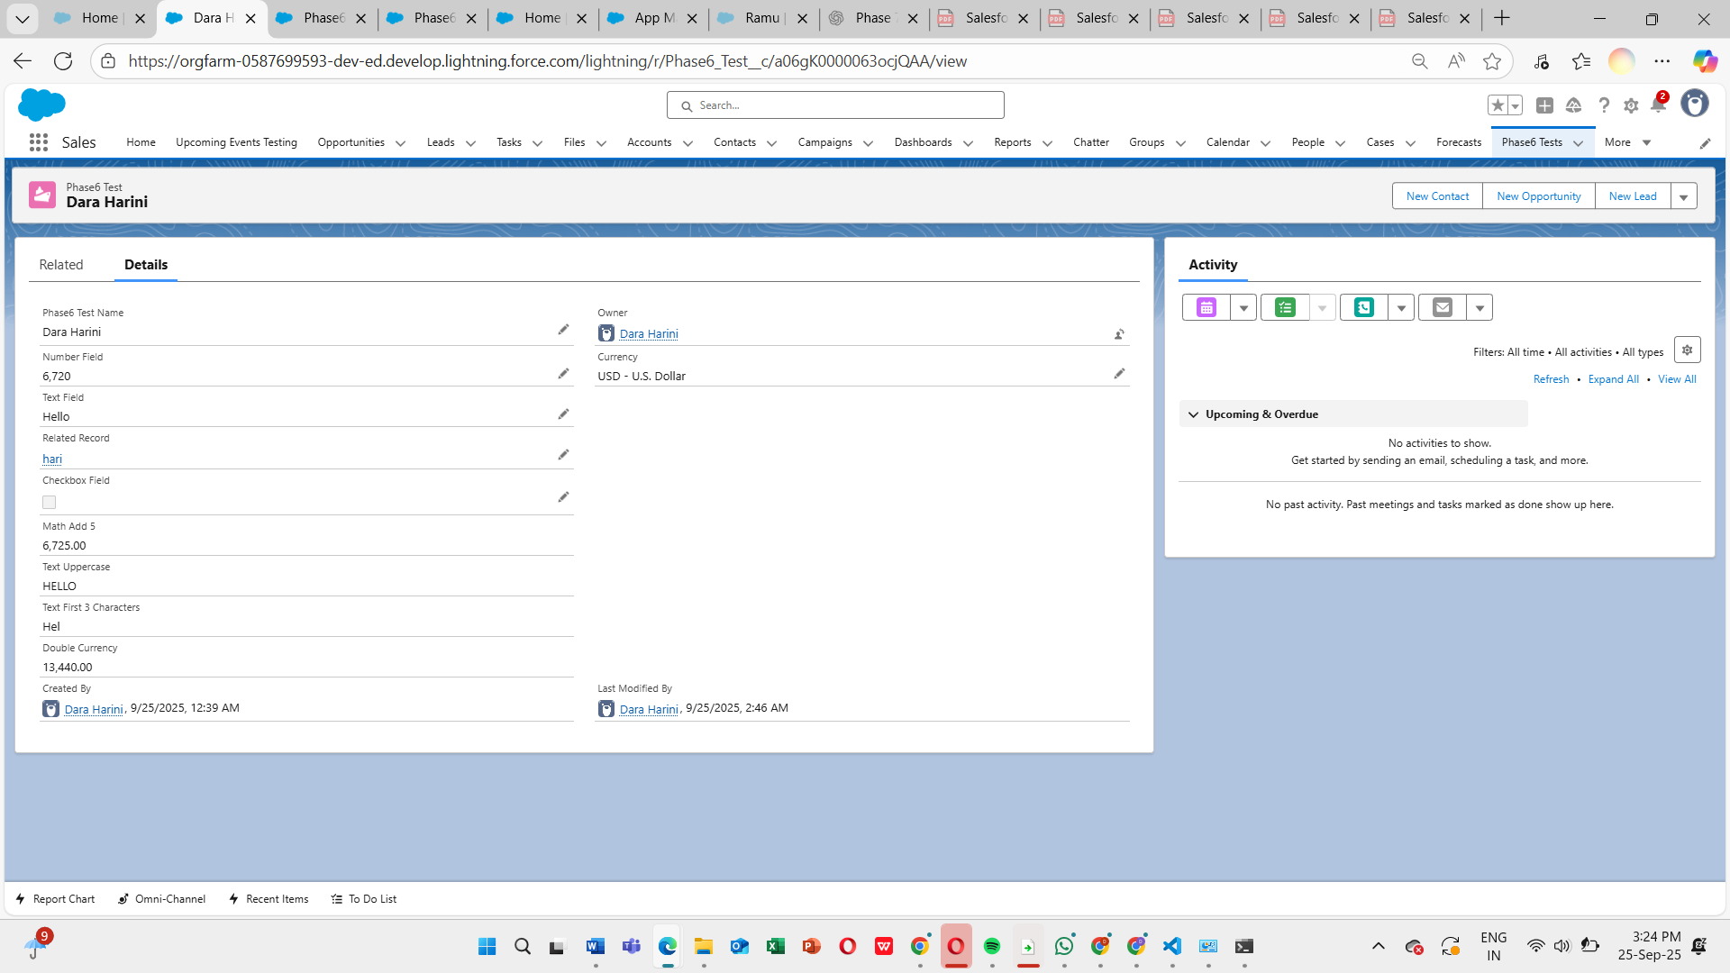

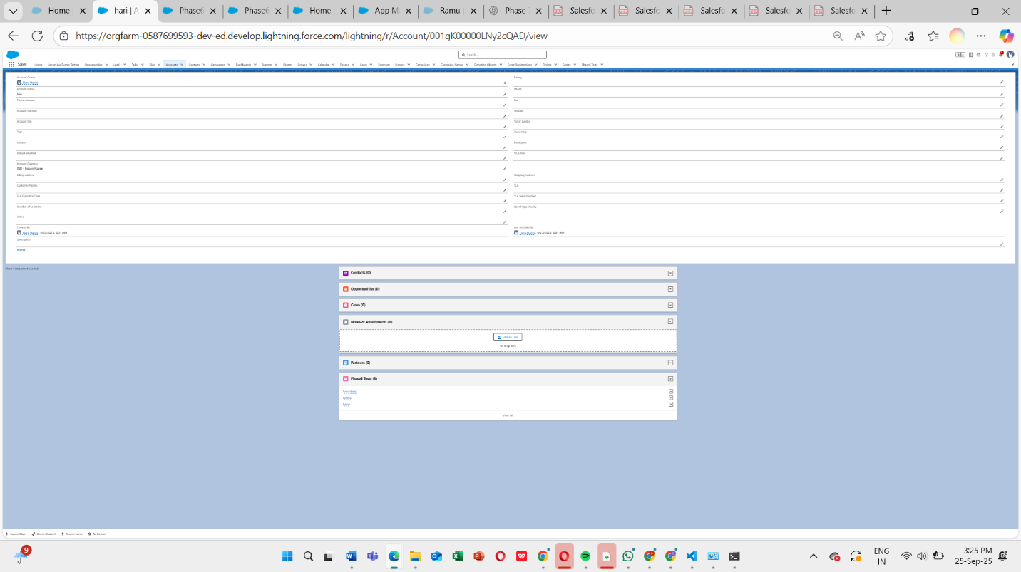

**Phase 7: Integration & External Access - Submission Document**

**Use Cases:**

1. **External Payment Gateway Integration:**
   * Donations from online payments are automatically recorded.
2. **Data Synchronization:**
   * Keep donor management systems or external databases updated in real time.
3. **Secure API Access:**
   * Use named credentials and authentication to ensure safe external connections.
4. **Scalability:**
   * Supports NGOs that work with multiple donation platforms simultaneously.

**1. Named Credentials**

*Definition:* Securely store authentication details for external systems.

**Steps:**

1. Setup → Named Credentials → New Named Credential.
2. Enter URL, authentication type, and required credentials.
3. Save and test connection.

**Observation:** Connection to external service successful.

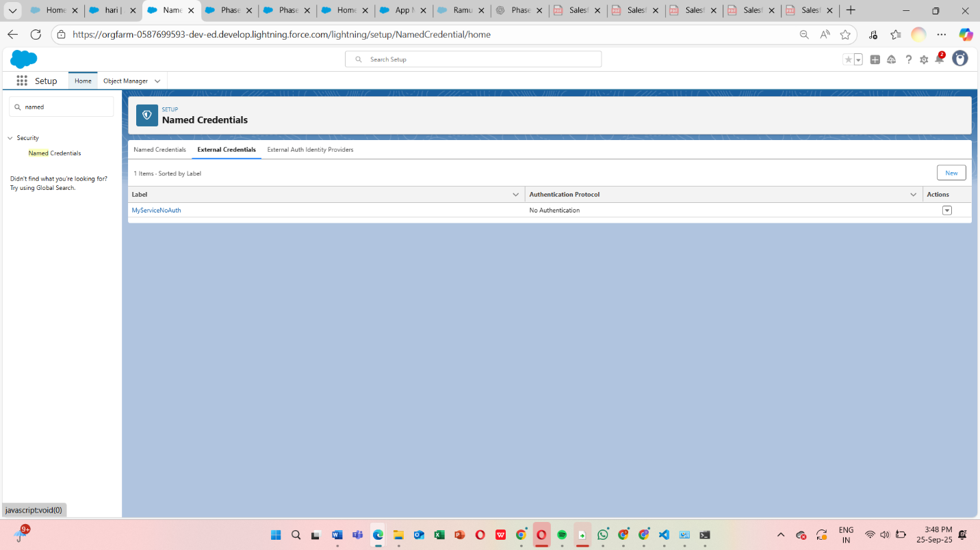

**2. External Services**

*Definition:* Integrate external API services declaratively.

**Steps:**

1. Setup → External Services → Register Service.
2. Import OpenAPI specification.
3. Generate Apex actions.
4. Test generated actions in Flow or Apex.

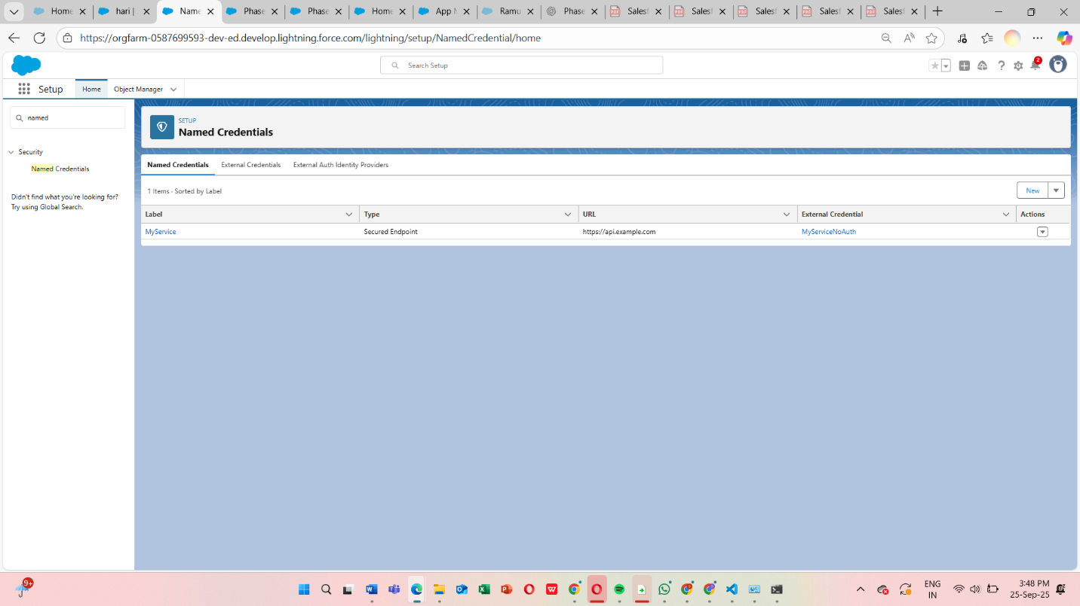

**3. Web Services (REST/SOAP)**

*Definition:* Use REST or SOAP endpoints for integration.

**Steps:**

1. Create Apex class with @RestResource for REST or WSDL2Apex for SOAP.
2. Test endpoint using Postman or Salesforce.
3. Verify request and response.

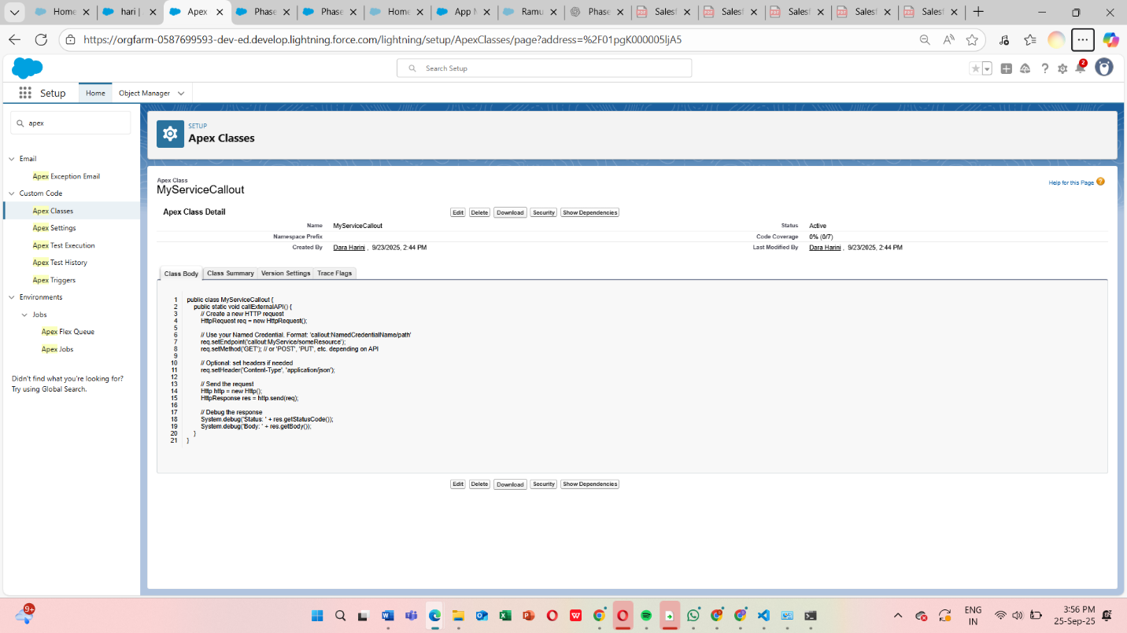

**4. Callouts**

*Definition:* Make HTTP requests from Apex to external systems.

**Steps:**

1. Create Apex class with HttpRequest/HttpResponse.
2. Add Remote Site Settings for external endpoint.
3. Execute callout and verify response.

**Code Snippet:**

HttpRequest req = new HttpRequest();

req.setEndpoint('https://api.example.com/data');

req.setMethod('GET');

Http http = new Http();

HTTPResponse res = http.send(req);

System.debug(res.getBody());

**5. Platform Events**

*Definition:* Custom events used for event-driven architecture.

**Steps:**

1. Setup → Platform Events → New Platform Event.
2. Add custom fields.
3. Publish event via Apex or Process Builder.
4. Subscribe using Trigger, Flow, or LWC.

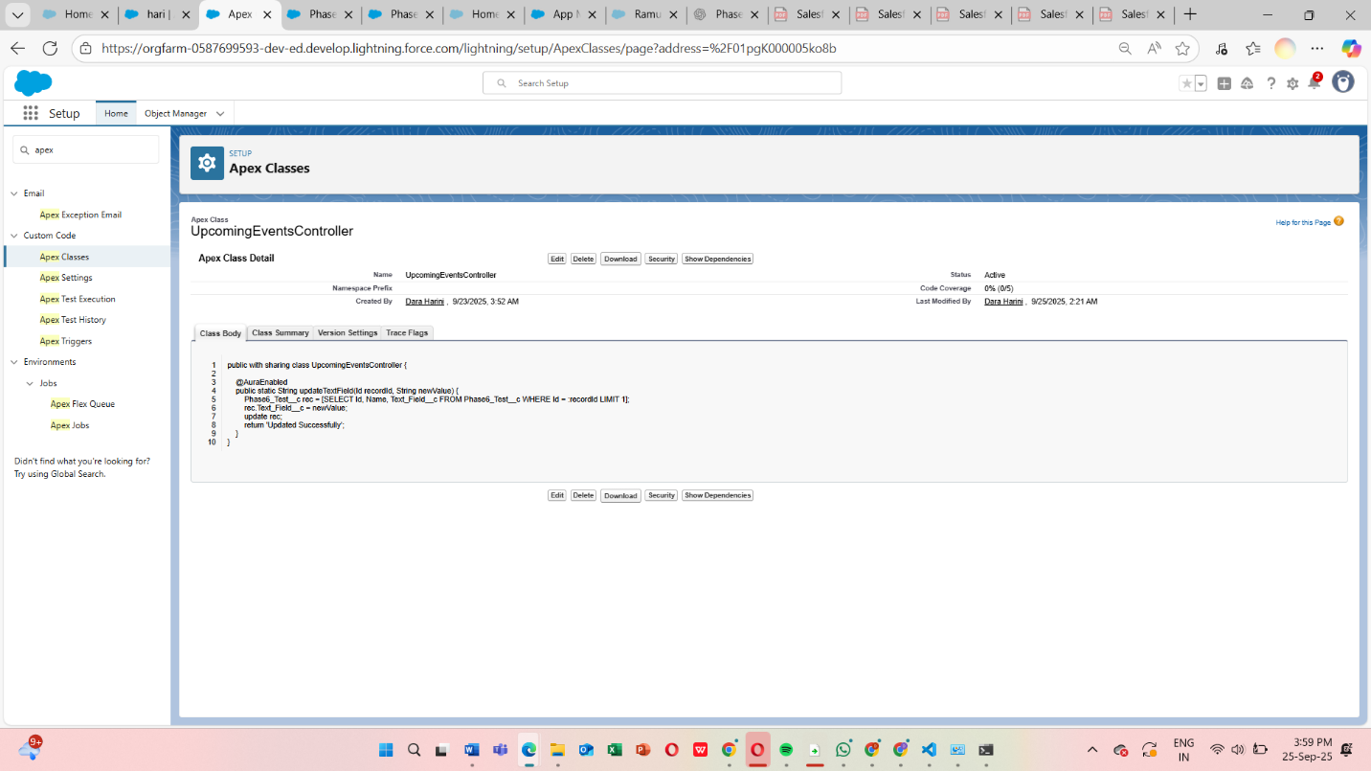

**6. Change Data Capture (CDC)**

*Definition:* Capture changes in Salesforce records in real time.

**Steps:**

1. Setup → Change Data Capture → Enable for required objects.
2. Subscribe using CometD client or Apex Trigger.
3. Verify record change notifications.

**7. Salesforce Connect**

*Definition:* Access external data in real time without storing in Salesforce.

**Steps:**

1. Setup → External Data Sources → New.
2. Configure authentication and object mappings.
3. Create External Object.
4. Verify external data accessible in Salesforce.

**8. API Limits**

*Definition:* Monitor the number of API requests to prevent hitting governor limits.

**Steps:**

1. Setup → System Overview → API Usage.
2. Monitor limits during callouts and integrations.
3. Adjust integration frequency if needed.

**9. OAuth & Authentication**

*Definition:* Secure authentication for external systems via OAuth.

**Steps:**

1. Setup → Connected Apps → New.
2. Configure OAuth scopes and callback URL.
3. Test OAuth flow using external system or Postman.

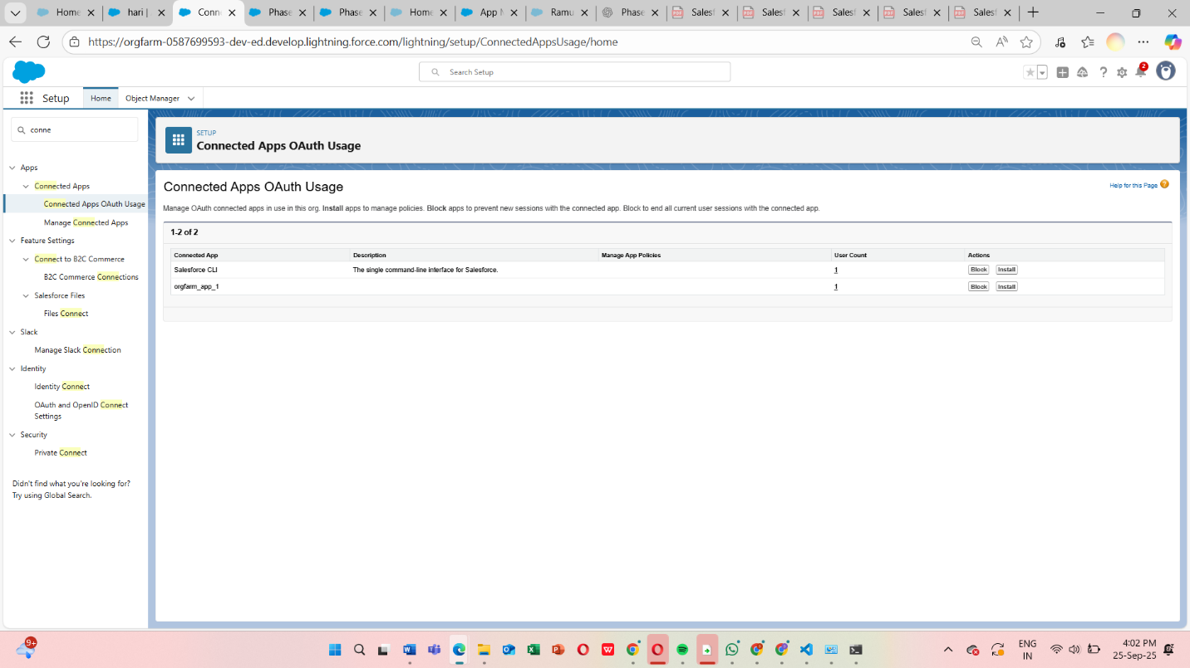

**10. Remote Site Settings**

*Definition:* Allow Salesforce to make callouts to external URLs.

**Steps:**

1. Setup → Remote Site Settings → New.
2. Enter external URL and name.
3. Save and verify callout success.

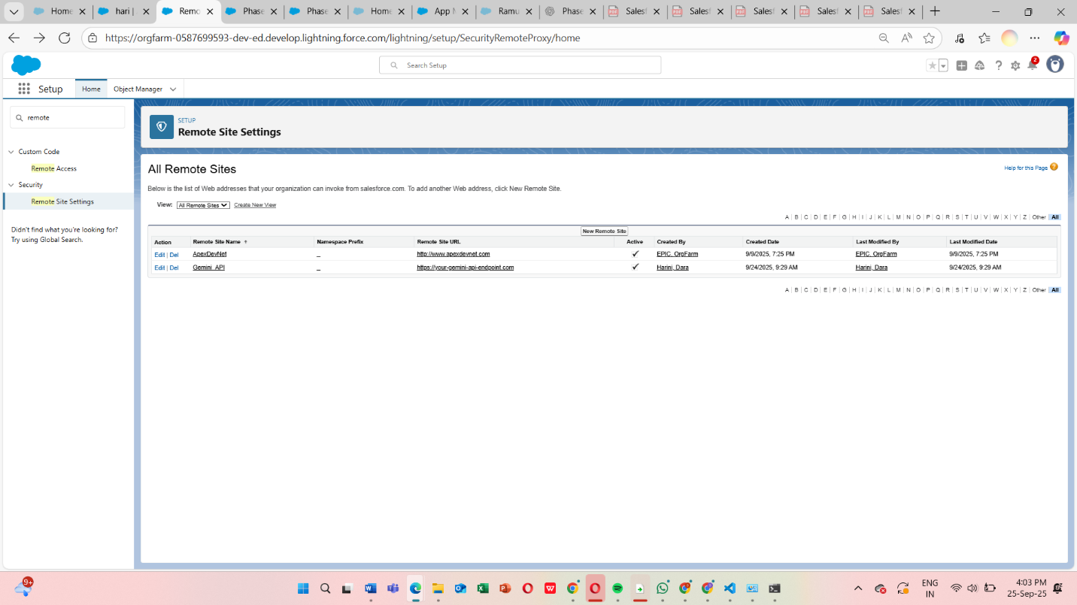

**Phase 8: Data Management & Deployment**

Phase 8 focuses on managing donation, donor, and campaign data efficiently, importing/exporting records, and deploying configurations between Salesforce orgs. Proper data management ensures accuracy, reduces duplication, and allows smooth deployment from sandbox to production.

**Steps / Demo Actions**

1. Open **App Launcher → NGO Donation System → Donations tab → List View**.
2. Show **existing donation records**, emphasizing accurate data entry.
3. Mention **Data Import Wizard / Data Loader**:
   * Used to bulk import donor, campaign, and donation records.
4. Mention **Deployment Tools**:
   * **Change Sets, VS Code SFDX, ANT Migration Tool** for moving objects, automation, and configurations between orgs.
5. Highlight **Duplicate Rules** (optional):
   * Prevent creating duplicate donor or donation records.
6. Return to **Home Page / Donations tab** to continue demo flow.

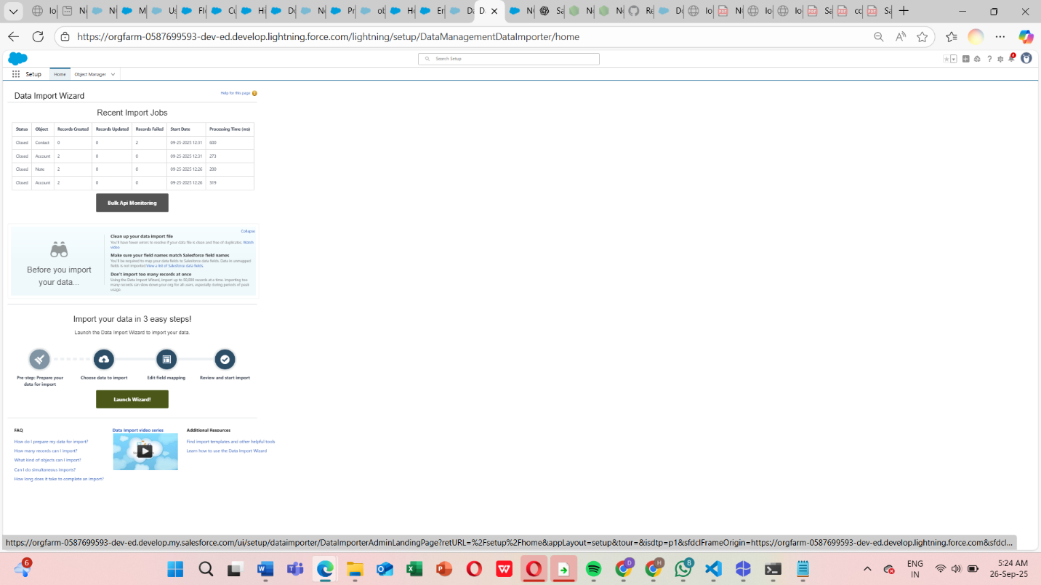

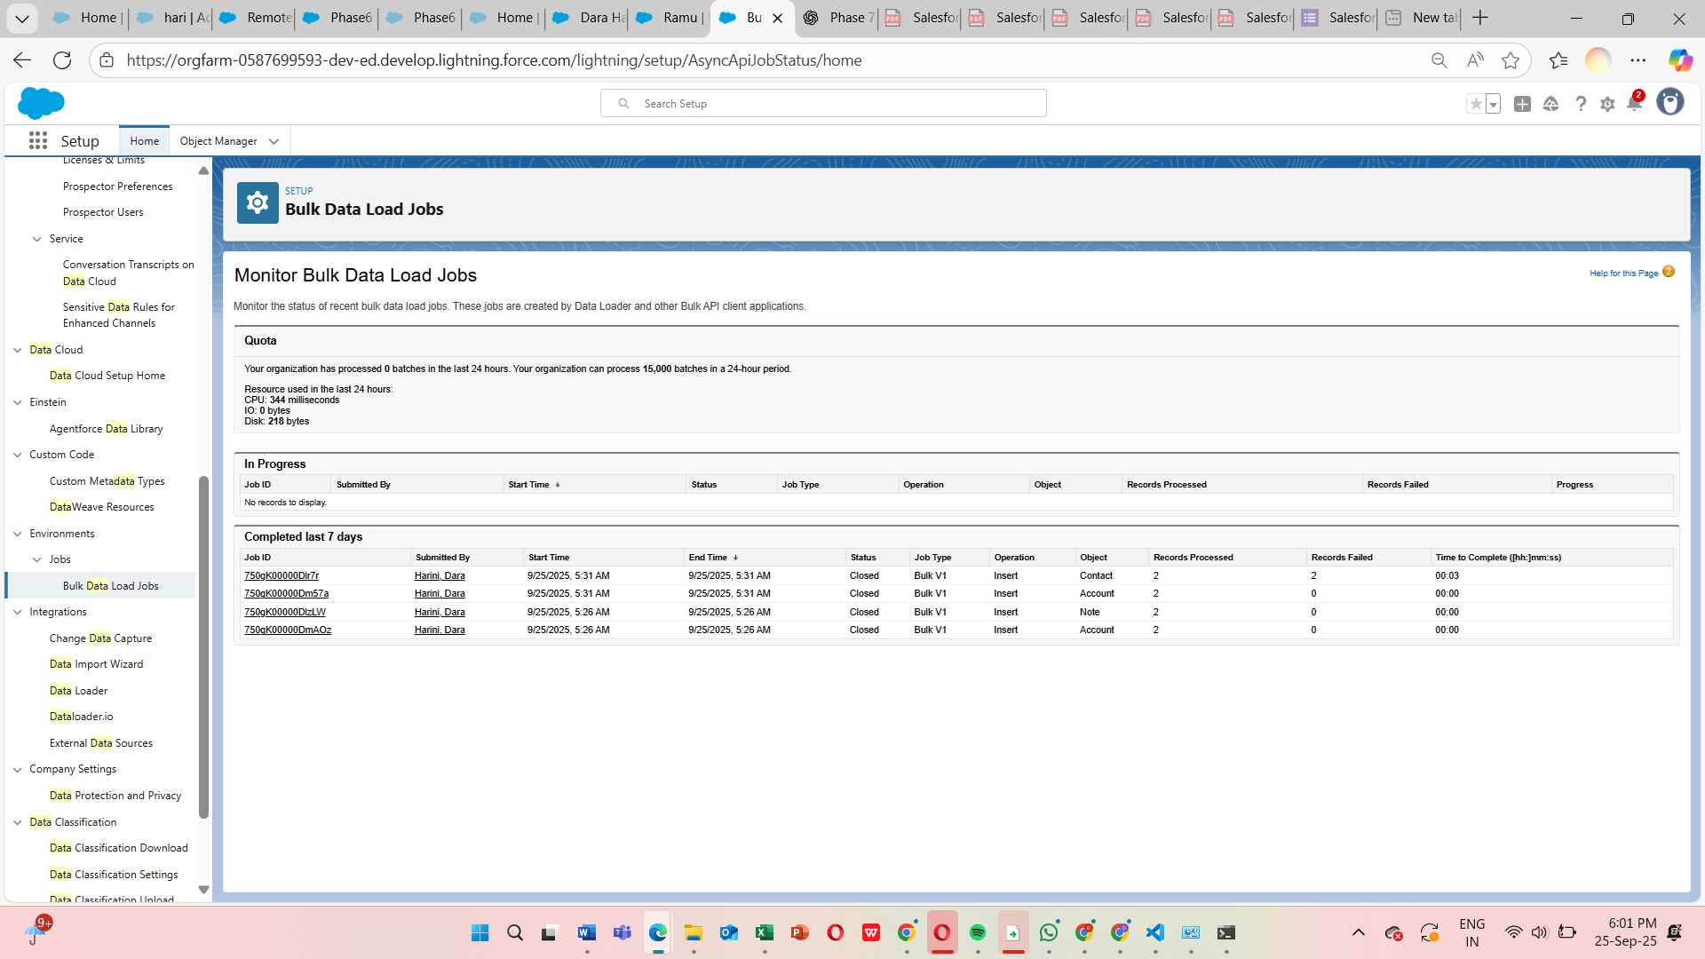

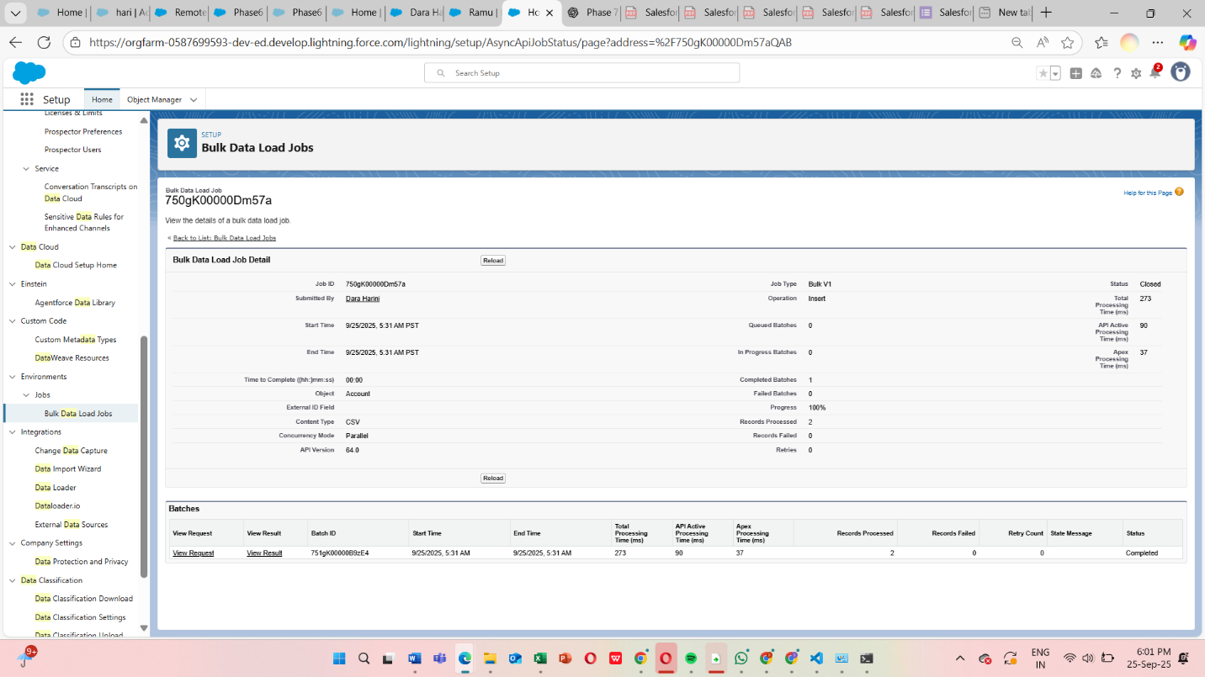

Use Case:

1. **Bulk Data Import:** Import multiple donor or donation records at once to save time.
2. **Data Backup & Export:** Export records for audits or offline analysis.
3. **Deployment Across Orgs:** Move configuration, objects, and automation safely from sandbox to production.
4. **Duplicate Management:** Ensure no duplicate donor or donation records exist, maintaining data accuracy.

**Benefits**

* Saves time managing large volumes of data.
* Reduces errors and duplicates.
* Ensures consistent data and configuration across environments.
* Supports scalability and future updates.

**Phase 9: Reporting, Dashboards & Security Review**

Phase 9 focuses on generating insights from donation data through reports and dashboards, and ensuring data security through role-based access control and permissions. This allows NGOs to track campaign performance and monitor donations effectively.

**Steps / Demo Actions**

1. **Reports:**
   * Open **App Launcher → NGO Donation System → Reports tab → Donations by Campaign**.
   * Click **Run** → show totals, high-value donations, and donor contributions.
2. **Dashboards:**
   * Open **Dashboards tab → Donation Overview**.
   * Show visualizations: total donations per campaign, high-value contributions, trends over time.
3. **Security / Role-Based Access:**
   * Filter List View by Fundraising Officer = Alice Smith → show only assigned donations.
   * Optionally, log in as a Fundraising Officer → show restricted access.
   * Admins can see all records and reports.

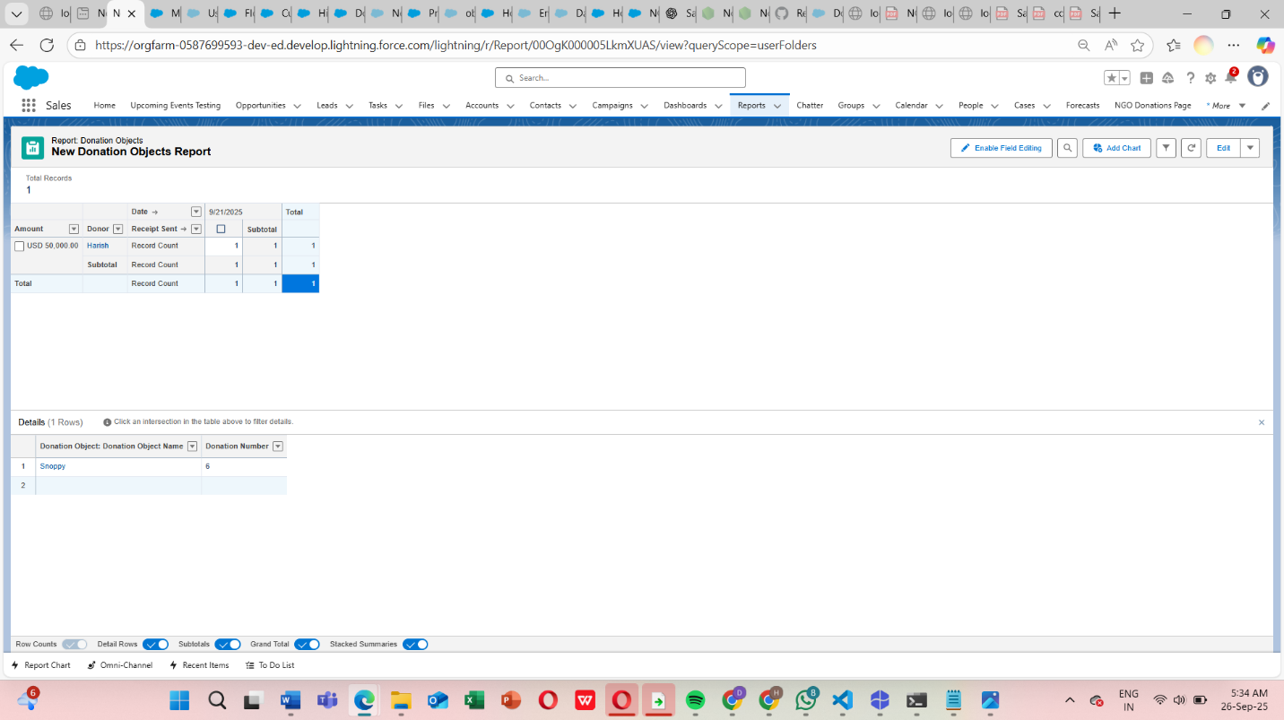

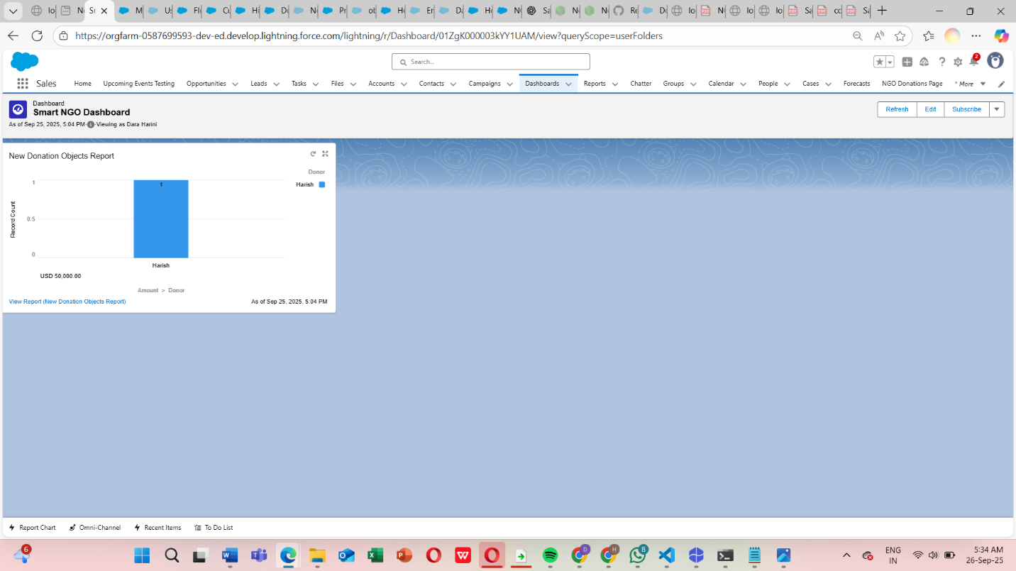

**Use Cases**

1. **Donation Reports:** Generate detailed reports by campaign, donor, or officer.
2. **Dashboards:** Visualize donation trends, campaign performance, and high-impact contributions.
3. **Role-Based Access Control:** Fundraising Officers see only their assigned donations; Admins have full access.
4. **Real-Time Insights:** Provide NGO management actionable insights to improve decision-making.

**Benefits**

* Enables data-driven decision making.
* Provides transparency for fundraising performance.
* Ensures sensitive donor and donation data is protected.
* Helps track progress against fundraising goals in real time.

**Appendix:** useful commands, sample metadata layout & test-data commands

SFDX: create project / scratch org / package

# create project sfdx force:project:create-n ngo-platform

# authenticate to Dev Hub sfdx auth:web:login-d-a DevHub

# create scratch org sfdx force:org:create-s-f config/project-scratch-def.json-a NGO_Scratch-d 7

# push source sfdx force:source:push-u NGO_Scratch

# run apex tests sfdx force:apex:test:run-u NGO_Scratch--wait 10--resultformat human

# create unlocked package sfdx force:package:create-n NGOPlatform-t Unlocked-r force-app # create package version sfdx force:package:version:create-p NGOPlatform-d force-app-k MyPkgKey- wait 20

# install package (example) sfdx force:package:install--package 04tXXXXXXXXXXXX-u SandboxOrg-k MyPkgKey w 20 Sample test data creation (sfdx)

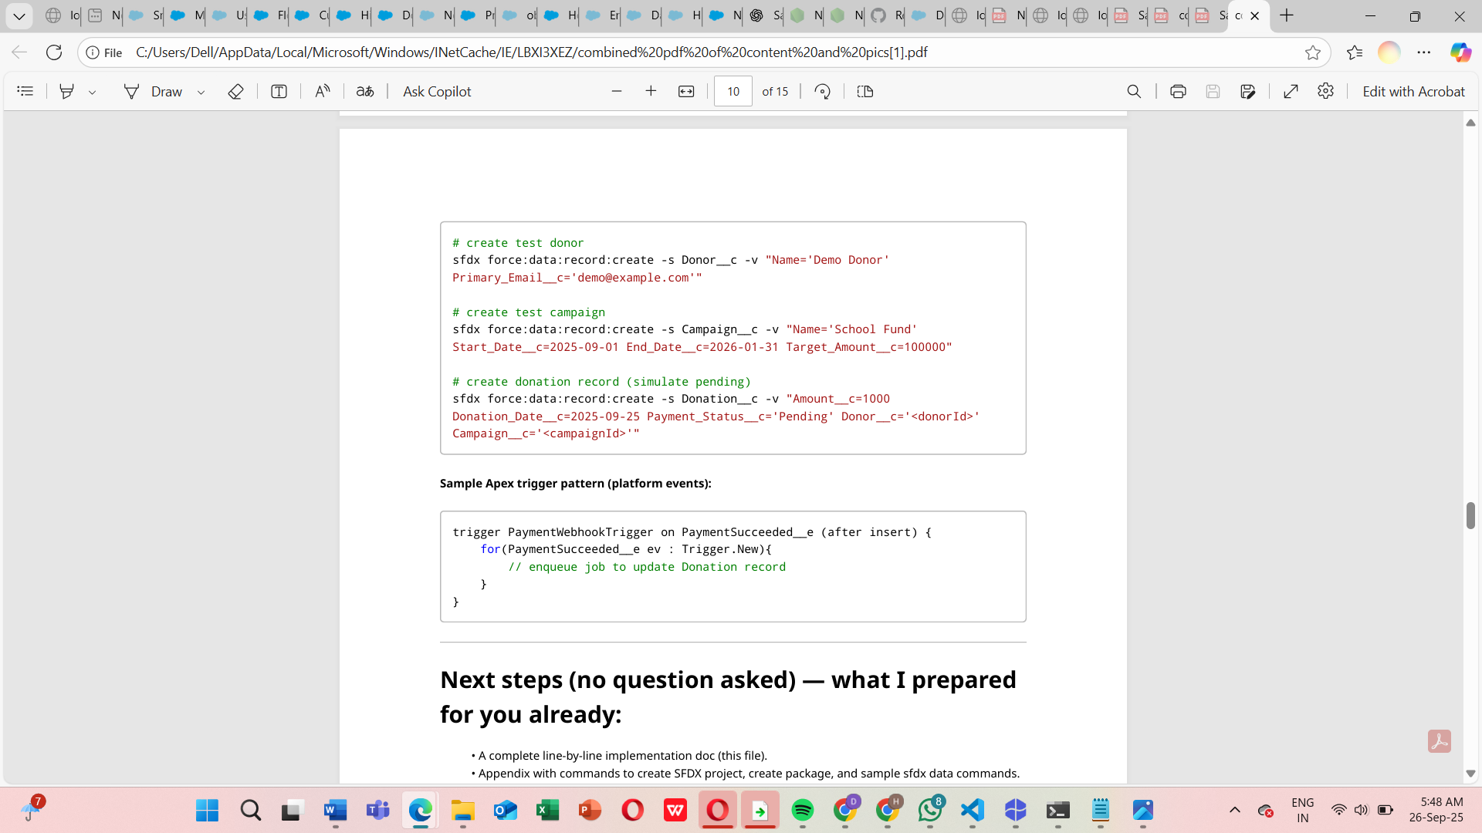

**Conclusion**

The **AI-Powered NGO Donation System** built on Salesforce streamlines the entire donation management lifecycle. Starting from **organization setup, data modeling, and automation** to **user-friendly interfaces, integration, data management, and reporting**, each phase contributes to solving the real-world challenges NGOs face with donation tracking.

By implementing this system:

* NGOs save time with **automated processes**.
* Fundraising teams respond faster with **real-time notifications**.
* Donor data remains **secure and role-based**.
* Management gains **actionable insights** from reports and dashboards.

This ensures NGOs can focus more on their mission and impact rather than manual data entry or reporting.

In short, this project demonstrates how Salesforce can be leveraged to build a **scalable, secure, and intelligent donation management system** that empowers NGOs to maximize their fundraising potential.